**BSc in Software Development**

**(Mobile Apps and Connected Devices)**

**Group Project 3**

Book, movies and game hub

James McQuade

James Cummins

Dillan Deegan

**Table of Contents**

Contents

Project Concept 3

Project Proposal 4

Why is the website called Sector 7? 4

Technologies to Be Used 5

Project Backlog 6

What changed in the planning between the product backlog and sprint 2? 8

Sprint 1 Backlog 11

Sprint 2 Backlog 18

System Architecture 31

Screen shots 32

What went wrong? 35

What are the new features if you register and login on our website? 35

Project Conclusions 36

References 38

# Project Concept

For our group project, our team has come up with an idea that doubles as an application and a website. This functions as an online store and information centre. Essentially, we will create a website that has a variety of books, movies and games from all different genres. The website will contain the image of the book, movie or game along with the description for the product. Naturally, the price of the product is included with a review of it. The more interaction you can see and do yourself, the better. This is our starting idea as a base. As time progresses, we will be looking to implement a store-like system that allows us to direct the user to a hub so they can purchase selected products. Along with this we will be adding a review system that will allow users to create an account and give their feedback on a product. This will be done by using a database.

The goal of the app is to recreate the website in a fully mobile version. The main feature will be the linked database – in that you’ll be able to login with the same credentials on the website and app, and vice versa. For starting the app, we will begin by creating our menu sections and linking the books, movies and games. This is just to give us a base to work with.

# Project Proposal

So, our task for this assignment was to basically create a project of our choosing whether it was to be an app, website or a raspberry pi project. After some discussions with all the team, we decided to go with a website and an app to go along side it. The reason we didn’t use a pi was that it’s just an extra device to set up without any defining features that would improve our project. The app is not simply a replica, but a companion app. Our website was to act as a social hub for lovers of books, movies and games. Our goal is to provide a space where users can find out more information about their favourite book, movie or game. We also are going to give our users the option to purchase said product and the chance to learn more about the people behind their product of interest. This includes learning about the author, directors and developers as well as getting a sneak peak of their upcoming projects. Other features include a timetable of products for the next 6 months, a product quiz amongst others. You’ll see them all within this report either in sprint 1 or sprint 2.

As mentioned above, we wanted to implement an app to coexist with the website as well as be its own piece. The goal here was to create an app with a login feature that linked back to the main database. This would allow the user to create an account on the app and use it as well on the website and vice versa. The app would act as a smaller more mobile version of the app but as a group we wanted to make the website the main focus. As a result, while working on the app we had to keep in mind that it was the secondary focus. This was so we wouldn’t get side-tracked – we couldn’t base the app off anything if the website itself wasn’t created. This was our logic in concentrating on the website more.

# Why is the website called Sector 7?

We were thinking throughout the entirety of sprint 1 about the name of the website. It was originally the entertainment hub which, while defining what our project is quite well, it did seem a bit generic. As a result, we wanted a more stand out name. Nothing too dramatic or fancy, just something that rolls off the tongue and can be remembered. It popped into my head during research for games, thinking about the Final Fantasy series. It isn’t an actual place in any of the games, but the name Sector followed by other numbers is.

# Technologies to Be Used

We had several technologies used throughout our project. It was a well - rounded project in terms of all the coding languages. For the front end, which was mainly our website, we used HTML for the base of it. So, the info such as authors, book details etc. are all HTML. The CSS is used to style the features we have, to make it look better. This is especially relevant for the timetables at the end of each page.

JavaScript was used to scroll the images in the slideshow at the end of all the product pages. These show the books, movies or games featured on the page you’re on, changing every two seconds. The other main feature of scripts within the pages was the age ratings we put in for security reasons. This was so people would know what sort of content was on the pages. For example, when you load the books page, it says 16+ content. The movies and game pages say 18+ content. It’s a simple jQuery popup.

As I just mentioned, that was the JavaScript for the scripts within the pages. As you’ll see at the bottom of all pages, we have individual JavaScript pages within a folder. This is shown below.

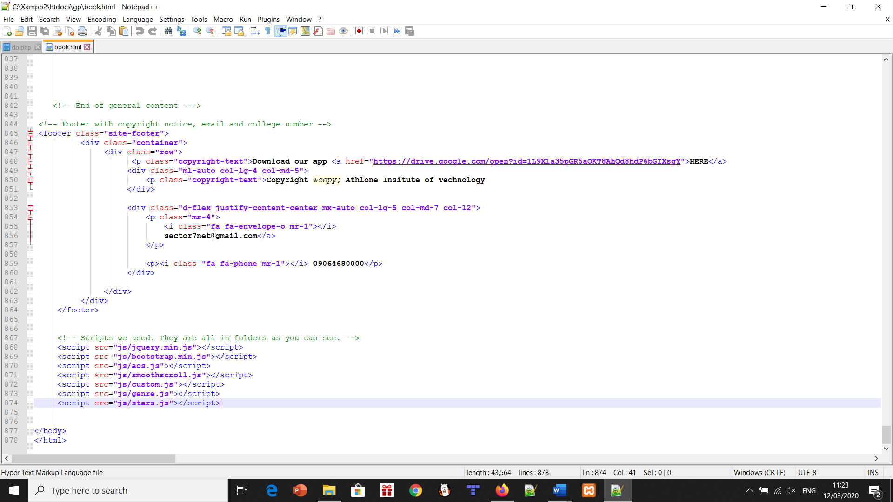

The app was created on Android Studio, an IDE we used the past year in our Mobile Apps module. To create the way the app looked, we used XML. This is for everything from the headings of each book, to the paragraphs detailing what a certain game is about. The java classes were used to create the functionality of the pages. Basically, being able to go from the home screen to books, movies or games is handled here. You can click a link which brings you to the Amazon page of the product. The link and button clicked event is handled here.

With the database, the main languages were PHP and MySQL. The SQL was used to create the database itself where php was used to code the functions of the database such as get, request, post etcetera. As well as this php Is where we also attempted the encryption side for the users password however due to a number of issues this had to be removed however we are well aware in the working world everything would need password protection and encryption.

# Project Backlog

I’ll give a brief description of the product backlog, as it will be described in much greater detail further below in the sprint 1 and sprint 2 headings.

Linking all pages within the website:

This was one of the first things we did. It’s important to have a solid base to start any website, and this project was no different. We created the home page, books, movies and games pages to start with. Just having these pages up and running gave us a good base to work with, and we could start dividing up the work. For example, Dillan did the movies page, James Cummins did the games page and James McQuade did the books page.

Content on all pages:

As I just explained above, the three main pages were split evenly. We all researched our own favourite books, movies or games. This included the description of the product, several reviews from different critics and links to the creators of the product. For most, we were able to find links to trailers or websites pertaining to the specific book, movie or game.

Purchase options:

Being able to actually buy something that you’re interested in is a main point of our project. The overall feeling is – we want people to be able to take info in and do something with that. The links always goes to an amazon page about the product.

Login system base:

The layout for the database was done here. This was simply creating the login and user page. Not much went into these apart from placeholders like “Welcome to Sector 7” until sprint 2.

Review system:

If you didn’t know about one of the products mentioned here before, you’d obviously want to know how well it was received, right? We picked three different critics from the world of books, movies and games for each product and put them in % terms. The review scroll bar below the image of Harry Potter and The Deathly Hallows, for instance, tells you straight away how it did. As a personal touch, we added the colour corresponding to the product as the progress bar colour. So, for Harry Potter, we chose the green colour as it represents the colour of his eyes and the spell that he was famous for surviving.

Refactoring:

This was a general tidy up of all code, checking for spelling errors and fixing all bugs we could find. We held off on this process until we had everything done in sprint 1, just before we began sprint 2. This was so we could start a new sprint knowing everything created so far has been refined, is working and isn’t untidy. It’s basically the last box to tick on both sprints before the completion of the project.

Database for login system:

The idea behind the login system was so that the user would get to feel a part of the website itself this was to be done by allowing the users to create an account on our website. To do this we used an application called xammp this allowed to create our SQL database this is where all the information regarding the user’s details would be sent and received.

Social media platforms:

We decided to create our own Twitter and Instagram page. We named them Sector 7. Having our own pages gave the project a sense of professionalism and another link for users to tie us to. They can follow either account or both if they wish. Future updates of the website will be published there. It also gives a personal side to us, the three people who created the project.

App creation:

The app was created after most of the front end (Website) was finished. As a result, we decided to add a small feature with the app instead of creating a standalone app that didn’t link in at all. As a result, we had the database linking between the app and the website, which will be elaborated upon in the individual sprints.

The only work in sprint 1 regarding the app was the base creation – the login page, books, movies and games. From there, sprint 2 was linking the database and user details along with actual info on the pages.

Information page:

This page changed significantly from sprint 1 to sprint 2. We originally had our social media platforms as symbol links along with a thank you to the user for accessing our site. As time went on, we decided to add to this page. There was a drop-down FAQ section instead, but keeping the social media links too.

Guest section:

This was basically every page in the website if you didn’t log in. There are less features compared to the logged in version. As they say, less is more. It serves its purpose as curiosity for users, enticing them to register and login – what other features did we add in?

# What changed in the planning between the product backlog and sprint 2?

The two screenshots below are the entirety of our overall backlog. As it turned out, the product backlog was just our sprint 1. This was because we decided to focus mainly on the front end getting finished as much as possible before sprint 2. We knew sprint 2 would be the back end, so database and linking usernames and passwords. As a result, the heavy lifting and creation of our project was done in sprint 1.

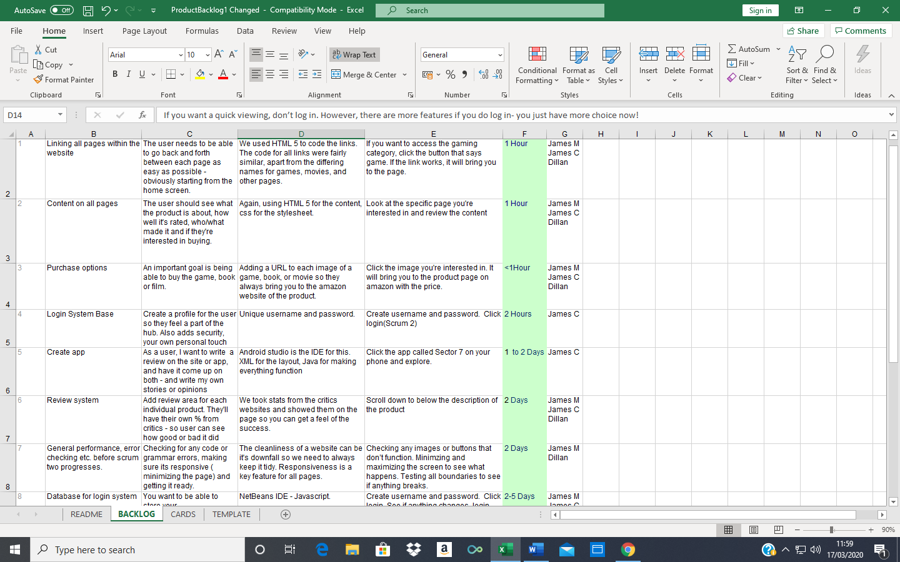

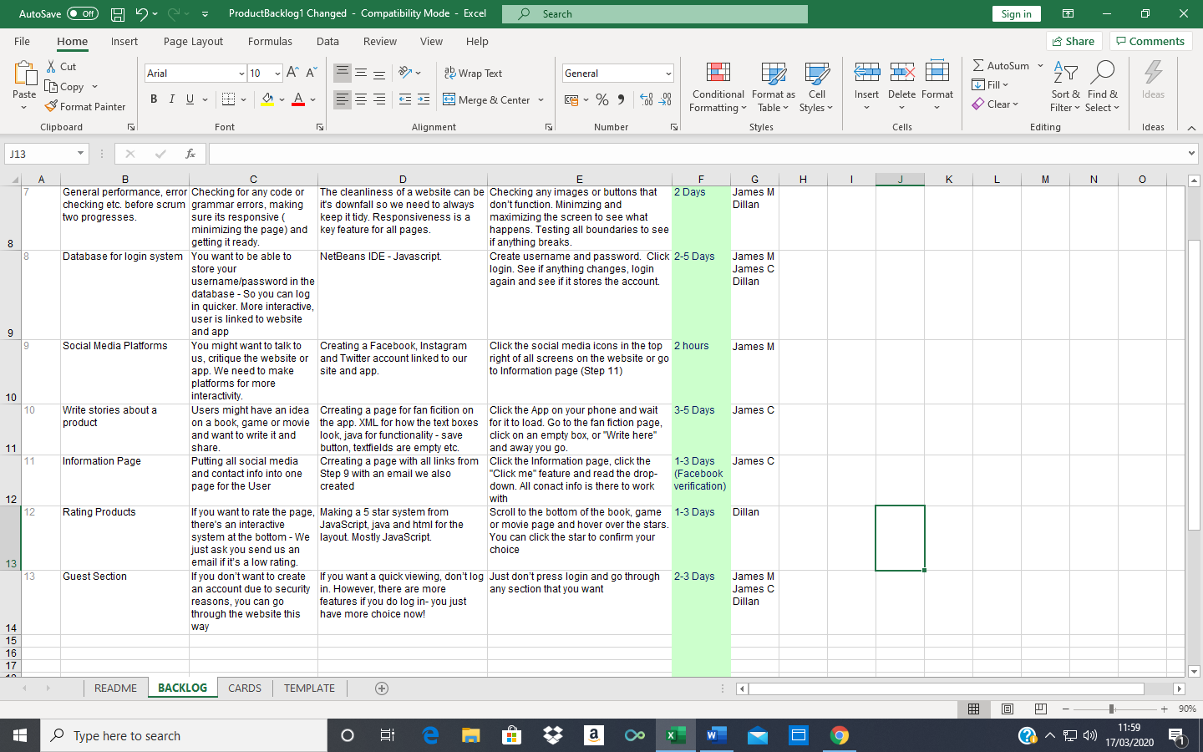

The screenshot below shows sprint 2. As I was saying above, most of the creation (So making pages for examples) was done in sprint 1. The only new pages added in was the user page and FAQ page from the information page done in sprint 1. Everything else was medium sized features being added into existing pages such as the review box. This doesn’t mean that this sprint was just small work, far from it. Two of the best features of the entire project are the user page and product quiz. They both add so much professionalism and realism to a proper website. They also bring much needed interactivity with the user. Having a page just for the person logging in was a big step to making it an all-round proper website.

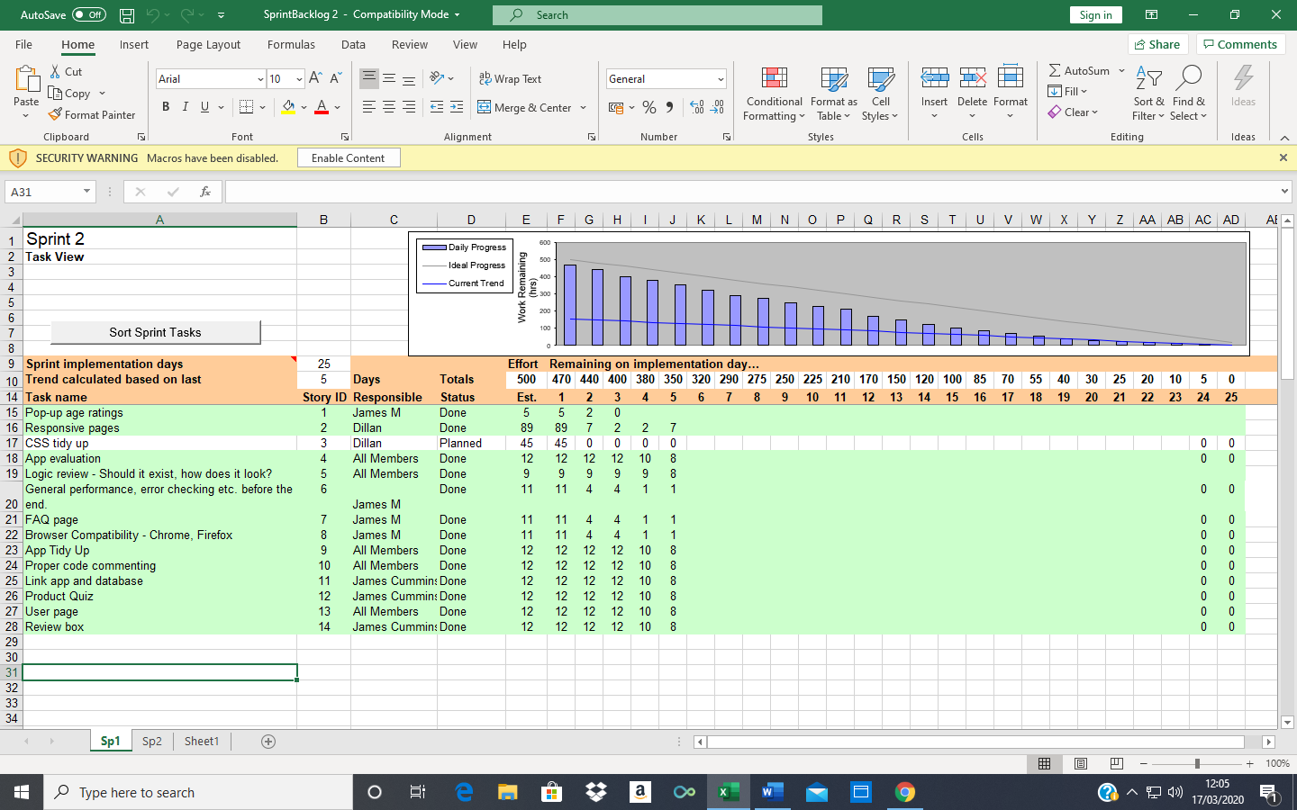

# Sprint 1 Backlog

Linking all pages within the website:

This was one of the first things we did. It’s important to have a solid base to start any website, and this project was no different. We created the home page, books, movies and games pages to start with. Just having these pages up and running gave us a good base to work with, and we could start dividing up the work. For example, Dillan did the movies page, James Cummins did the games page and James McQuade did the books page.

The screenshot below shows the code for what I’m talking about. This was also one of the main things we checked for during the refactoring process, broken links. It’s imperative that all links work and bring you somewhere. To build on this, we made sub-categories for each book, movie and game like fantasy, thriller and multiplayer respectively.

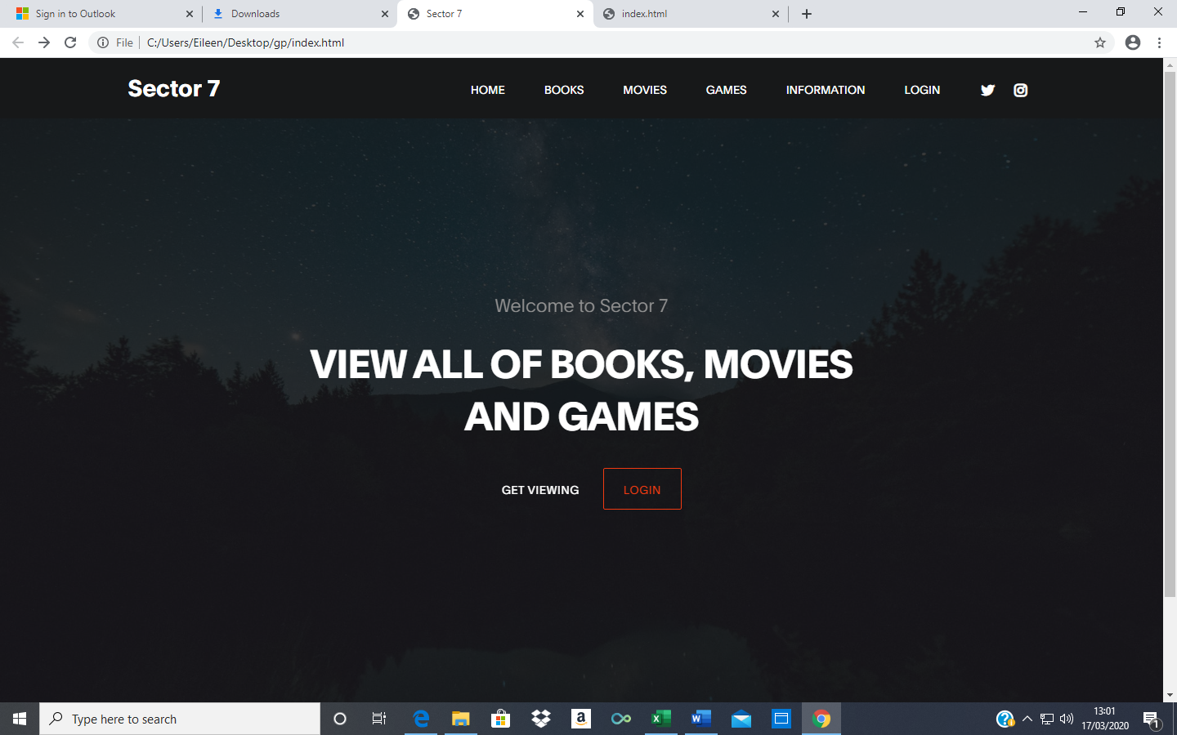

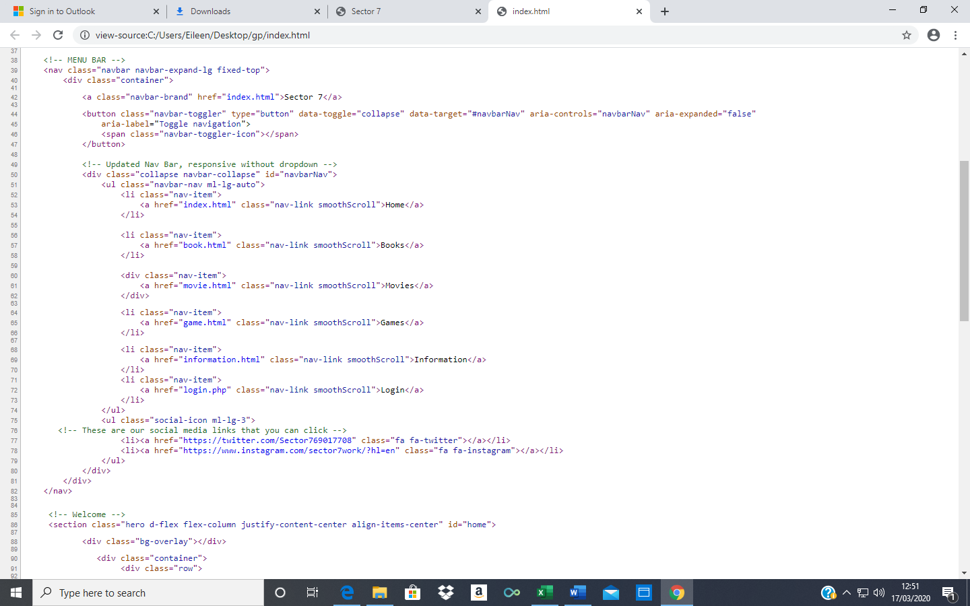

Content on all pages:

As I just explained above, the three main pages were split evenly. We all researched our own favourite books, movies or games. This included the description of the product, several reviews from different critics and links to the creators of the product. For most, we were able to find links to trailers or websites pertaining to the specific book, movie or game.

The screenshot below shows the summary of the book, the book cover along with the link to buy it and the reviews it got.

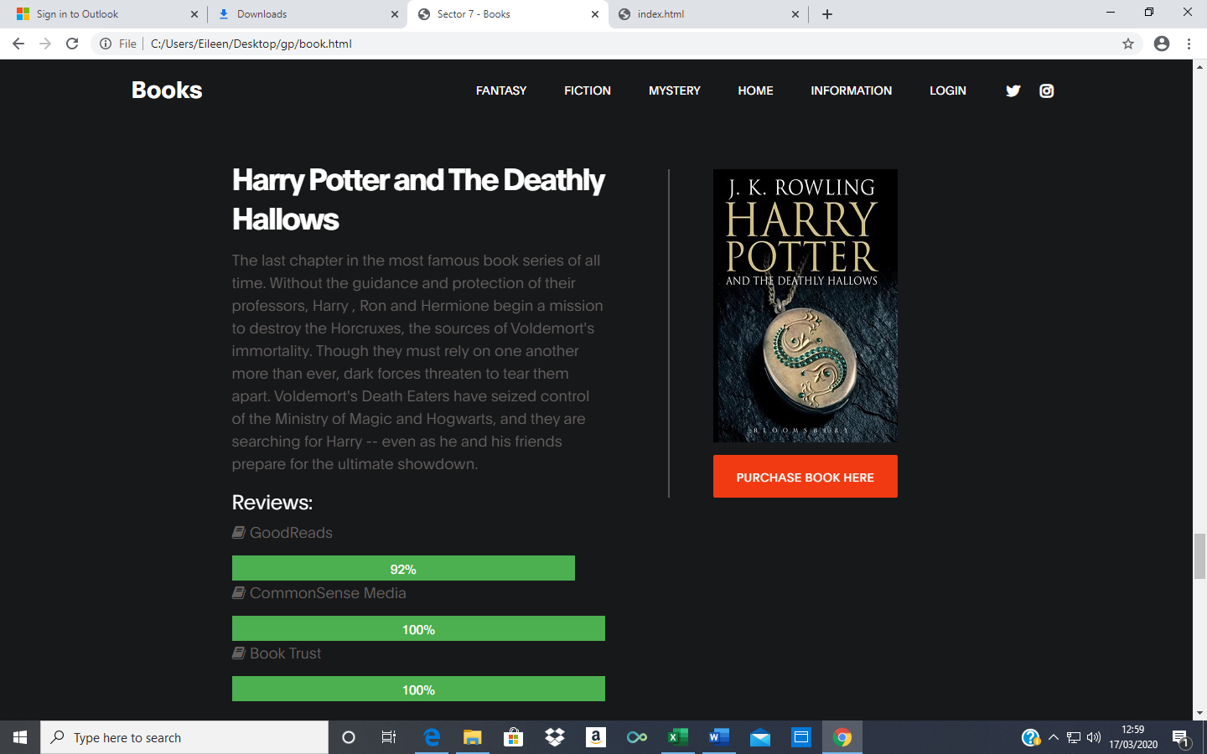

A nice little addition to each main book, movie and games pages was a timetable of upcoming products, as shown below. For us, but more importantly the users, it gave a sense of continuity – the website doesn’t just stop here, there are new things on the horizon. We chose to do the first half of the year for two reasons. One, most products wouldn’t have a concrete release date that far into the year. Two, most people would want something to look forward to in the near future, not in 8 months’ time. Again, like I’ve said, the website is built by us, but we look at it from the users point of view.

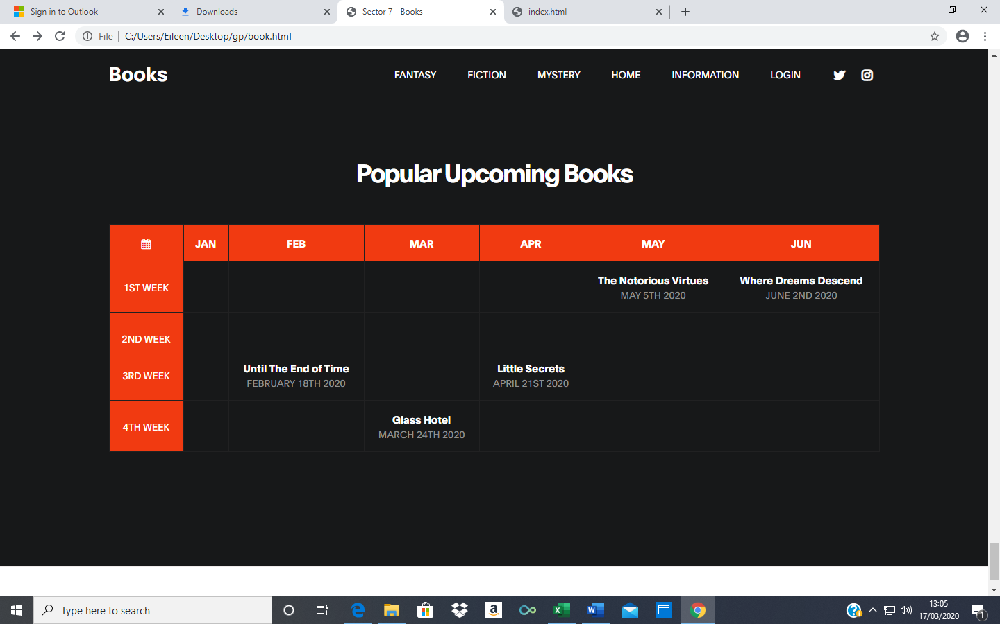

Purchase options:

Being able to actually buy something that you’re interested in is a main point of our project. The overall feeling is – we want people to be able to take info in and do something with that. The links always goes to an amazon page about the product.

As you can see below, this is the page the orange link brings you to.

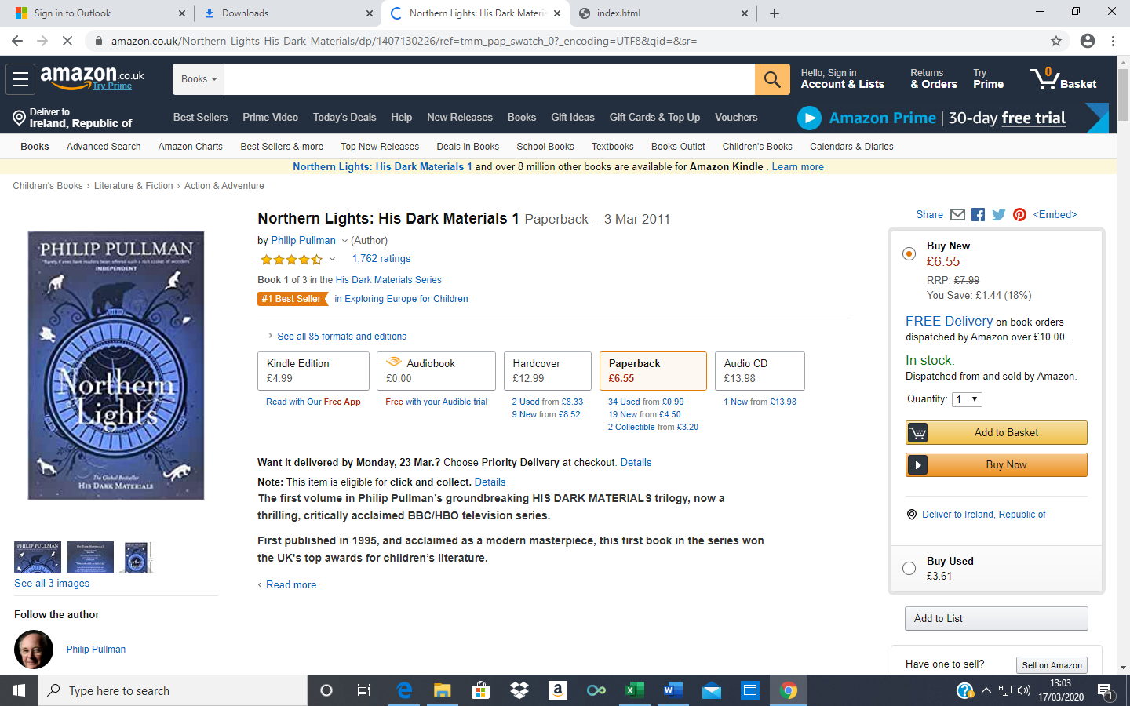

Login system base:

The layout for the database was done here. This was simply creating the login and user page. Not much went into these apart from placeholders like “Welcome to Sector 7” until sprint 2. So much more work went into the database than we originally thought.

Review system:

If you didn’t know about one of the products mentioned here before, you’d obviously want to know how well it was received, right? We picked three different critics from the world of books, movies and games for each product and put them in % terms. The review scroll bar below the image of Harry Potter and The Deathly Hallows, for instance, tells you straight away how it did. As a personal touch, we added the colour corresponding to the product as the progress bar colour. So, for Harry Potter, we chose the green colour as it represents the colour of his eyes and the spell that he was famous for surviving.

Overall, the review bar for each product gave it validation. They’re actual scores by actual critics, not made up by us because they’re our favourite books or something. Everything has to be official and real.



Refactoring:

This was a general tidy up of all code, checking for spelling errors and fixing all bugs we could find. We held off on this process until we had everything done in sprint 1, just before we began sprint 2. The main things I checked were that the links were all working, there was nothing out of place like a broken tag. Balancing was key – we had to make sure there was consistency throughout the three main pages, like a timetable in each or a footer at the end of the page. It’s basically the last box to tick on both sprints before the completion of the project.

Database for login system:

So as mentioned earlier we used an application called xammp to make the database, however another problem was deciding what language to do it in we had the options of coding it in php or java. From previous experience with java databases we decided to steer clear of java and went with the php route this was interesting for us as we have never done php before so learning it was going to be a new challenge for us. Thankfully learning php turned out to be quite enjoyable as once we had a grasp on it, it made the database so much easier to accomplish. Once our main database was established, we wanted to try and be more secure about it, so we tried to add encryption more specifically md5 however this caused a number of issues for the app side of things which is using the same database. This was because we were encrypting in php and trying to decrypting in java this caused us a number of issues when working the log in system form the app.

Social media platforms:

First, I made the Twitter account. It was named Sector 7, along with the Instagram account. I gave a brief description in the bio.

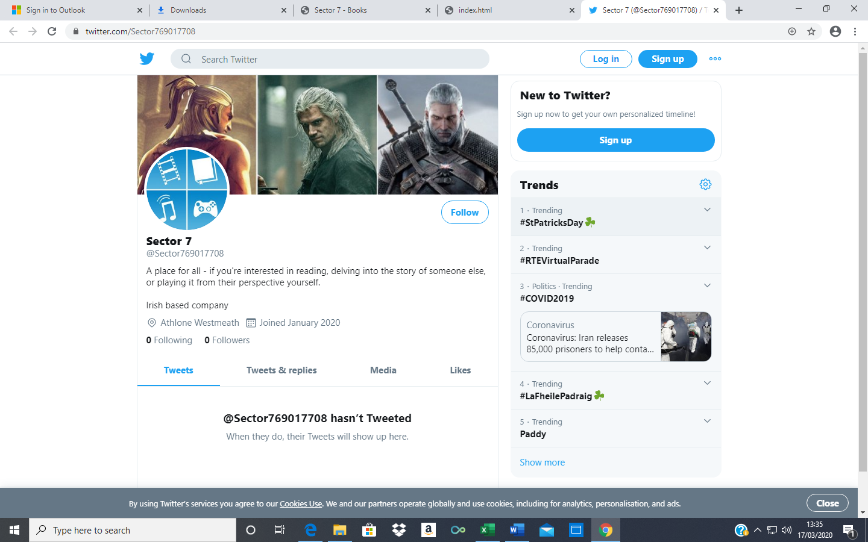

Next, I made the Instagram account. With this one, we gave it a more personal touch with a post. Through this, we get to connect with people easier and also give them a reason to connect with us.

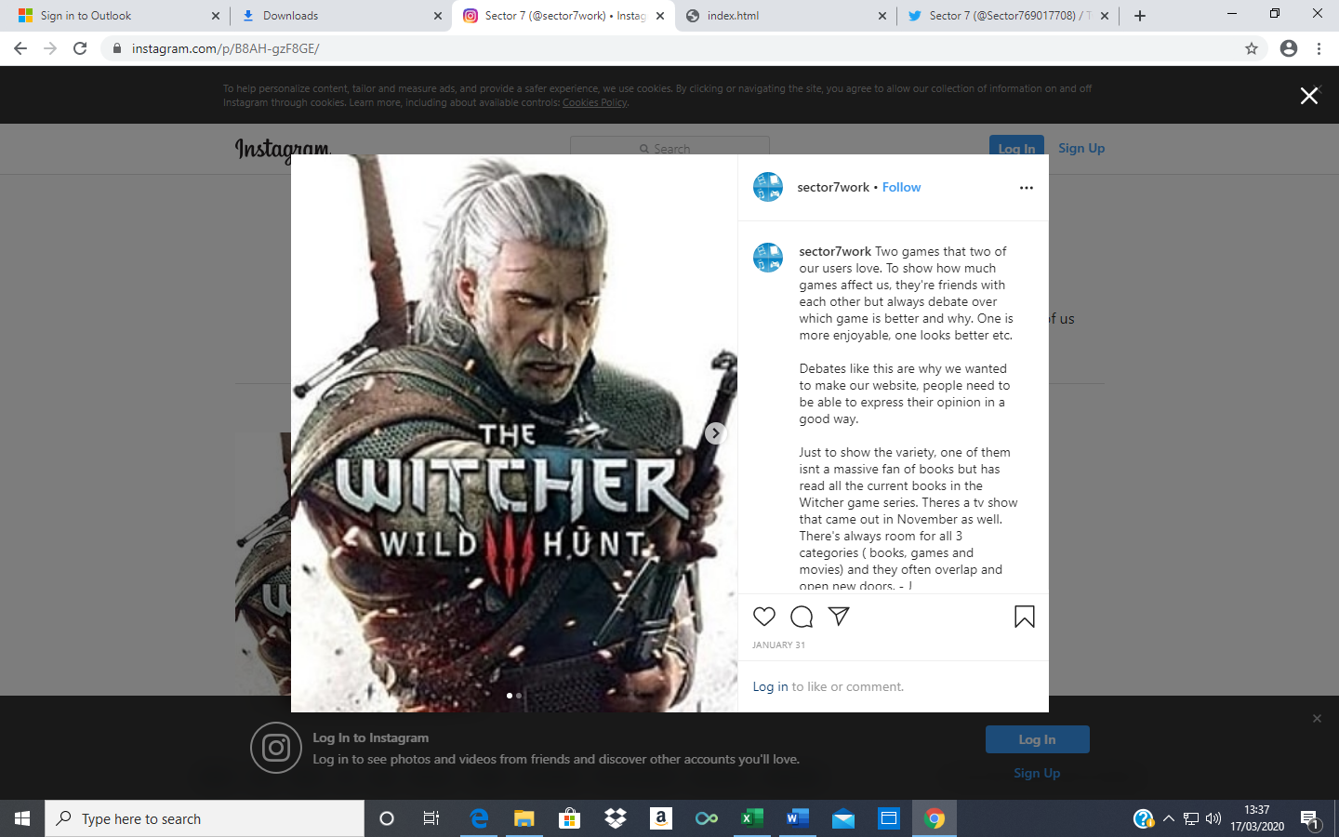

The two accounts were linked in the same way as the books page, for example, and then added to the nav bar as symbols of their platform.

App creation:

The app was made in Android Studio. The XML pages for the main page and 3 area pages were created here. At this time, they are just shells – the functionality isn’t there. There’s no info, simply ghost pages. This is quite similar to the start of the website.

There was a significant change between planning and executing the idea for the app. Originally, we wanted to implement a fanfiction service for users. This would mean they could write reviews, theories or other works about their favourite game, book or movie. They would be divided into genres like fantasy, similar to the website. We realised that mixing this with the database would be very difficult. Therefore, we changed the app to something similar to the website. You can still rate each product out of five stars, buy it or check out their wiki page (Or similar)

This will be explained in more detail in sprint two as we linked the database between it and the website. Along with this, we were finishing the app more or less at the same time.

Information page:

We created this page originally just for our social media platforms. We thanked the user for just entering our hub and gave them our contact details in case they wanted to ask us anything. This includes our Instagram, Twitter and email address. We included this as a click-me drop-down box. This page was made to have one place for contact.

The information page changes drastically from sprint 1 to sprint 2. It’s renamed the FAQ page and improved upon greatly.

Guest section:

The guest section was a key part of making our website more professional. We essentially have two sides, either you’re logged in with your own account or you’re not. If you’re not, you get access to most of the website. There are some features missing, like the user page, product quiz amongst others. This is to push people towards registering, so they get full access to our hub.

# Sprint 2 Backlog

This sprint changed the project from a functioning website and app to a well-worked professional piece. This was more about adding in features, cleaning up the overall look and creating a few small pages than massive upheaval. This was due to the amount of work we undertook in sprint 1, that we could dedicate an entire sprint to this sort of work instead of having to worry about adding in many new features and pages. Indeed, we had a group meeting about the logic of it all – is there too much, too many pages in the website, deciding what to add in purely based on performance and not just adding things in for the sake of it.

This set the tone for this sprint.

Pop-up ratings:

The reason for this addition was more security and an authentic feel for the users when they go to certain pages. This is only for the main book, movie and games pages. We were thinking, based off the products we picked, books would be for 16+. Meanwhile, movies and games are both 18+ to have a sort of safety net just in case. There are some movies that are generally 16+ but have certain scenes that are bloody or have adult themes, so we chose 18+ to cover it all.

The code for this was a simple script as you can see below.

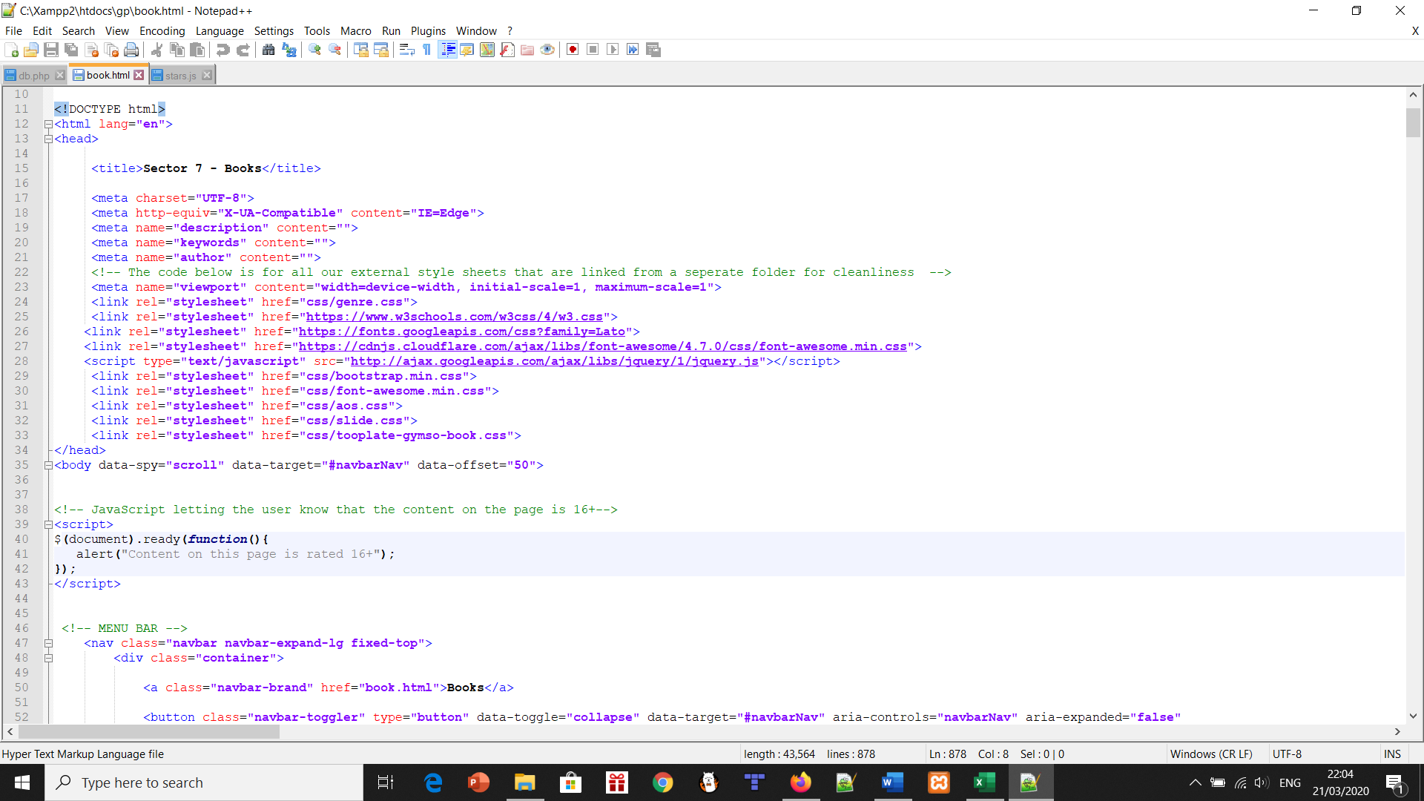

The pop-up shows upon loading the book, movies or games pages. Again, only the main base pages as you should access these first as a user.

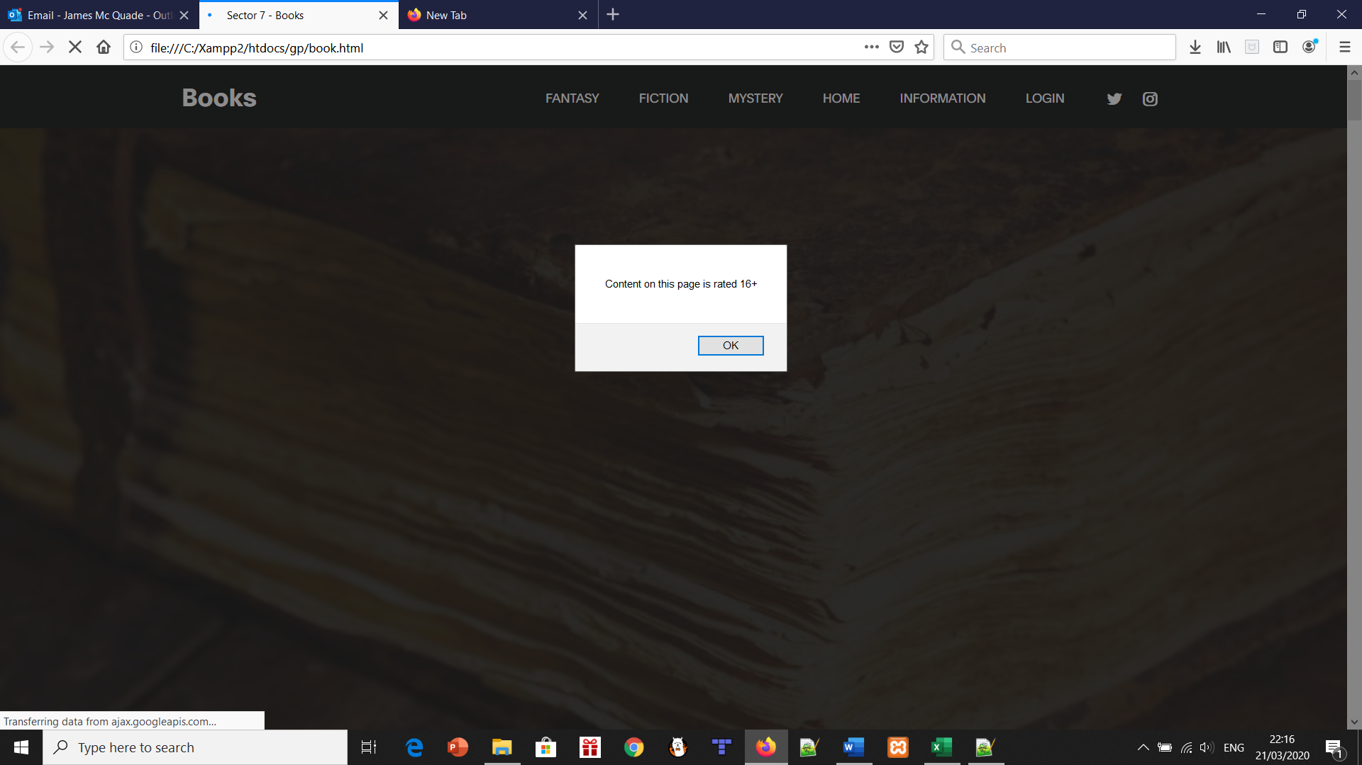

Responsive pages:

One of the main things we learned in previous years of learning about websites was to always make your pages responsive. Again, this is something that users appreciate about pages they visit every day, they play around and minimise the screen. The screen responds to them and their actions. Our website was responsive overall, but we had trouble separating the genres on the drop-down nav bar. As a result, we included the genres separately when you click the relevant category. For example, click books and then the genres like fantasy are inputted into the nav bar. The whole site was made fully responsive as a result. This was the result of several CSS pages that all link in.

The following screenshots are examples of what I was talking about.

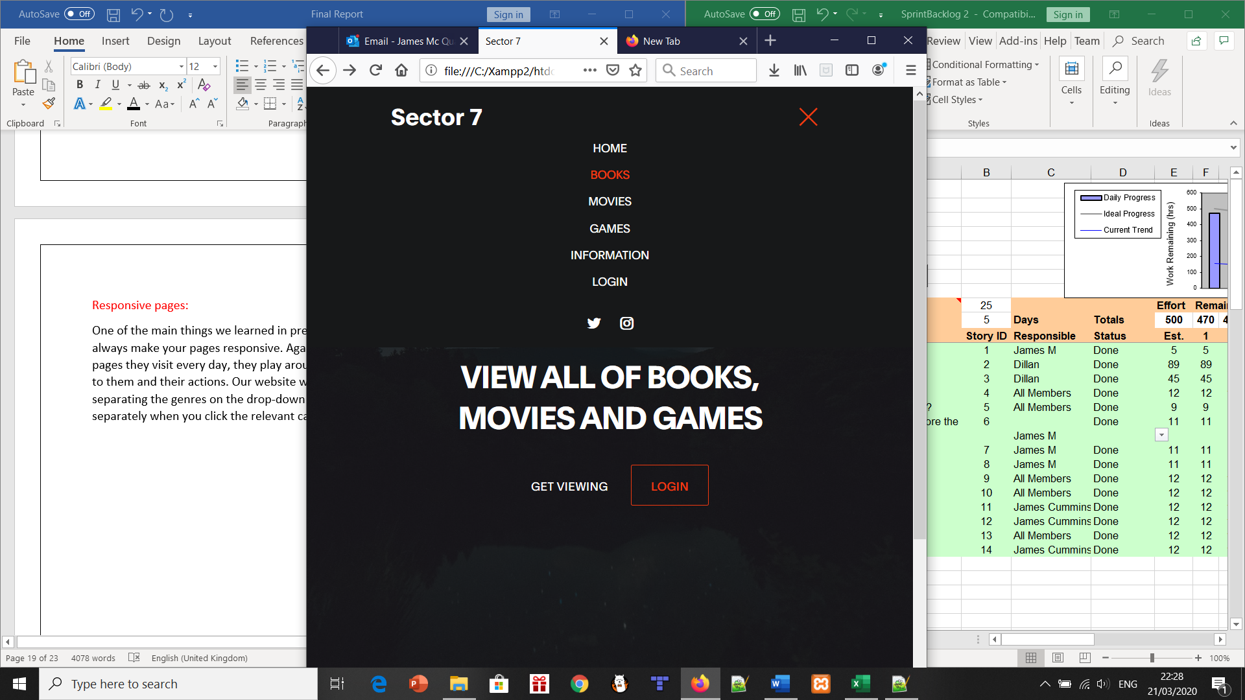 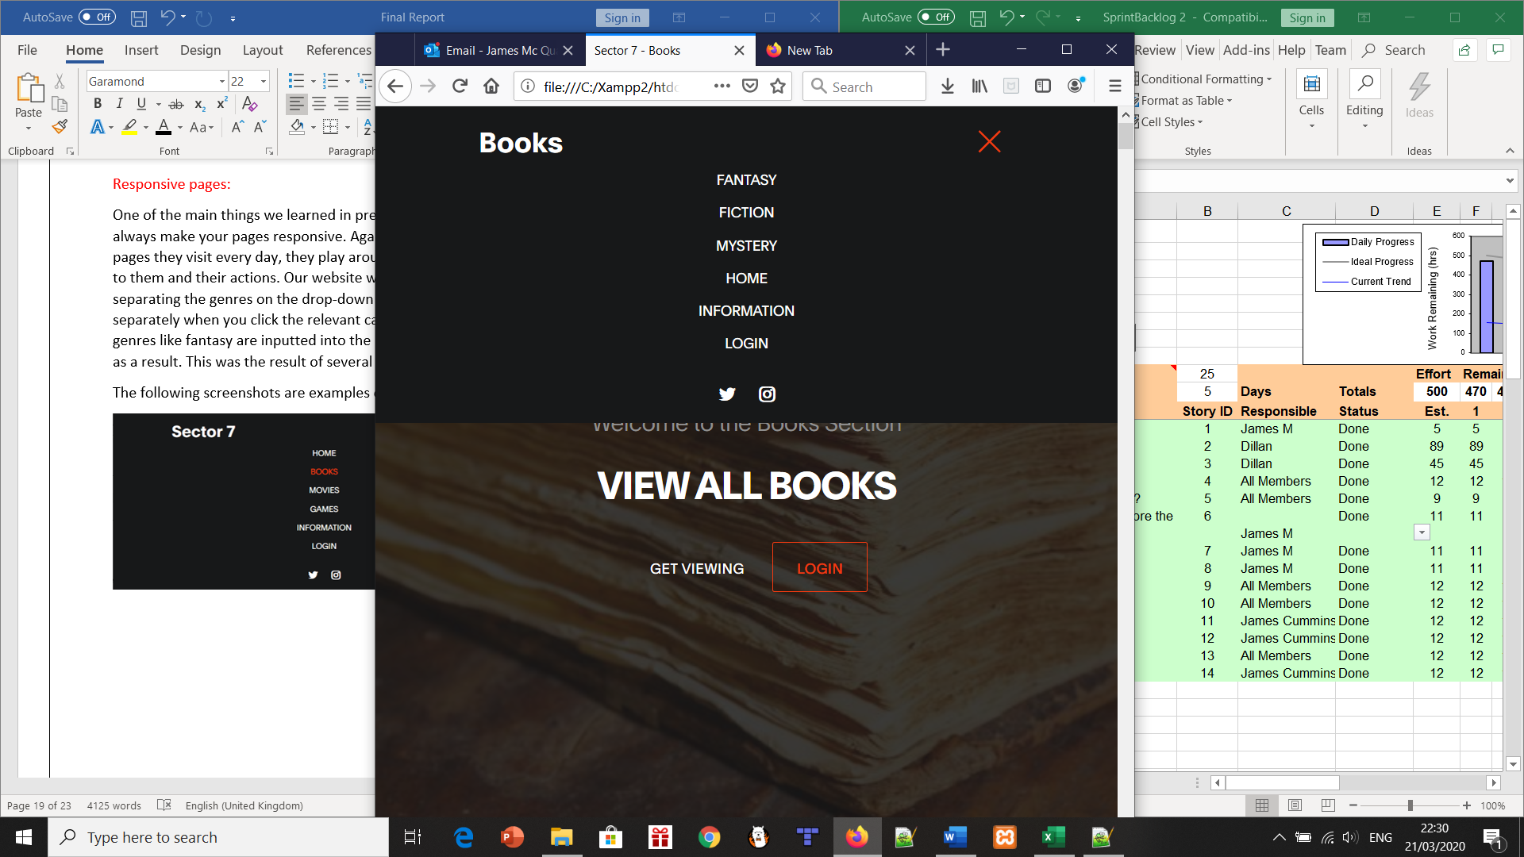

CSS tidy up:

For the project, a mixture of custom, W3 and the template website’s CSS was used when it came to creating the overall look of the website. The CSS was used to style the website by setting a base font, colour scheme and additional functionality such as the fade-up feature. There was also a drop-down for the FAQ and quiz pages.

The CSS also helped to create a more professional and responsive website that could be viewed on an app also. The navigation bar was able to be compressed and become a drop down to accommodate mobile/tablet users. The CSS also helped the format and layout by making things more centralised. This allowed for easier navigation on and between pages.

App evaluation:

This is where two in our group came together to decide what to do about the app and finish it in one sprint stage. James McQuade and James Cummins came up with the idea of a similar format to the website. James Cummins linked the database from the website to the app. This meant that people could use the same details to login on the website that they used to register and login on the app. This was the main feature of the app as we were told it would be a high mark feature in our first sprint presentation plan.

We then created the books, movies and games pages behind the login page – so you had to have an account to access the app, really. This was forced upon users as it involved the main feature of the app.

The pages had all the books in the book’s pages and so on and so forth. They also had the same reviews as the website. The difference was the % was translated to 1 out of 5 stars. There is also a review section for people to leave their own opinion on each product if they want.

As with the website, there are amazon links as well, directly to the purchase of whatever product you’re interested in. The app was exported to an apk file and uploaded to a OneDrive account. Further down the sprint outline, we will show where and how to access this.

Logic review:

We realised during the planning of this sprint that we were in danger of having an excessive number of things on our project. Primarily with the website, we knew we could only add in one more page to the navbar before it got cluttered looking. As well as this, the features we add into this sprint had to make sense and not just be there because it looks nice. This is the case with the product quiz and user page – both are important additions that complement the overall project.

The other thing to comprehend was the consistency throughout our website. If there was one feature on books, it had to be in games and vice versa. For example, we had a timetable for upcoming games and books but there was an empty space at the bottom of the movies page for no good reason. As a result, Dillan added in a timetable for movies as well.

General performance and refactoring:

For this sprint, we focused a lot on testing the performance of the database. More specifically, registering and logging in multiple times. This was fairly important in the grand scheme of things as the last thing we want is our database to not work, or broken links to pages. The database was the most intensive part of the work we accomplished, after all.

Another thing was checking the logged in pages and the guest pages. These are PHP for logged in and html for guests. It was basically cross-checking every page and making sure the navbar was the appropriate version. This could be quite confusing to differentiate between what pages are logged in, which pages need a logout page in the navbar etc.

FAQ page:

The information page from the first sprint was turned into an FAQ page by sprint 2. This isn’t to say we took out the info, or that it isn’t still a page of information for the users. James McQuade added a drop-down feature as you can see below. It’s a nice little feature that separates it from the other pages.

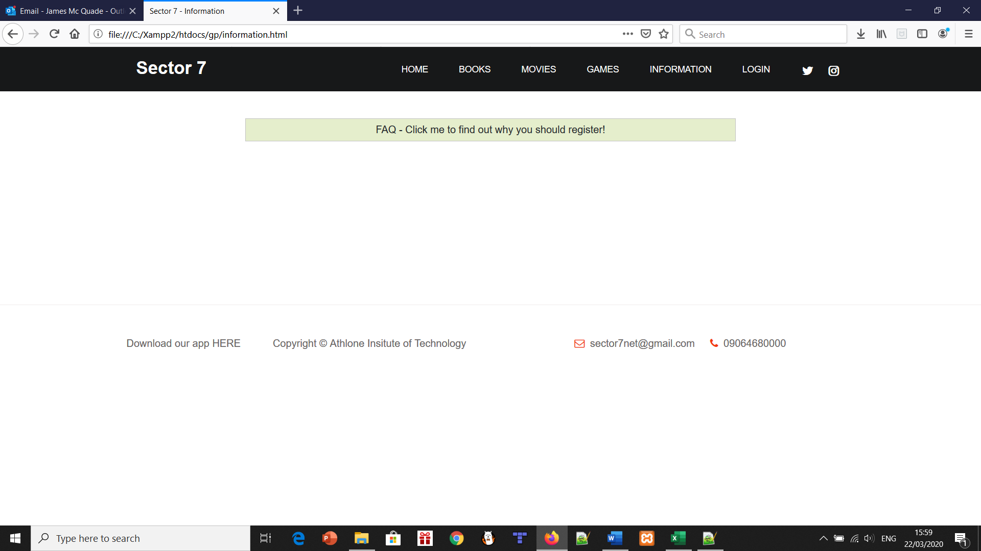

There are different versions of the FAQ page depending on if you took the time to register an account. The guest version is more focused on why you should make an account, our plans for the future and contact details. The contact details were an important piece to keep in from the original page. This is the aforementioned guest FAQ page below, as I just detailed.

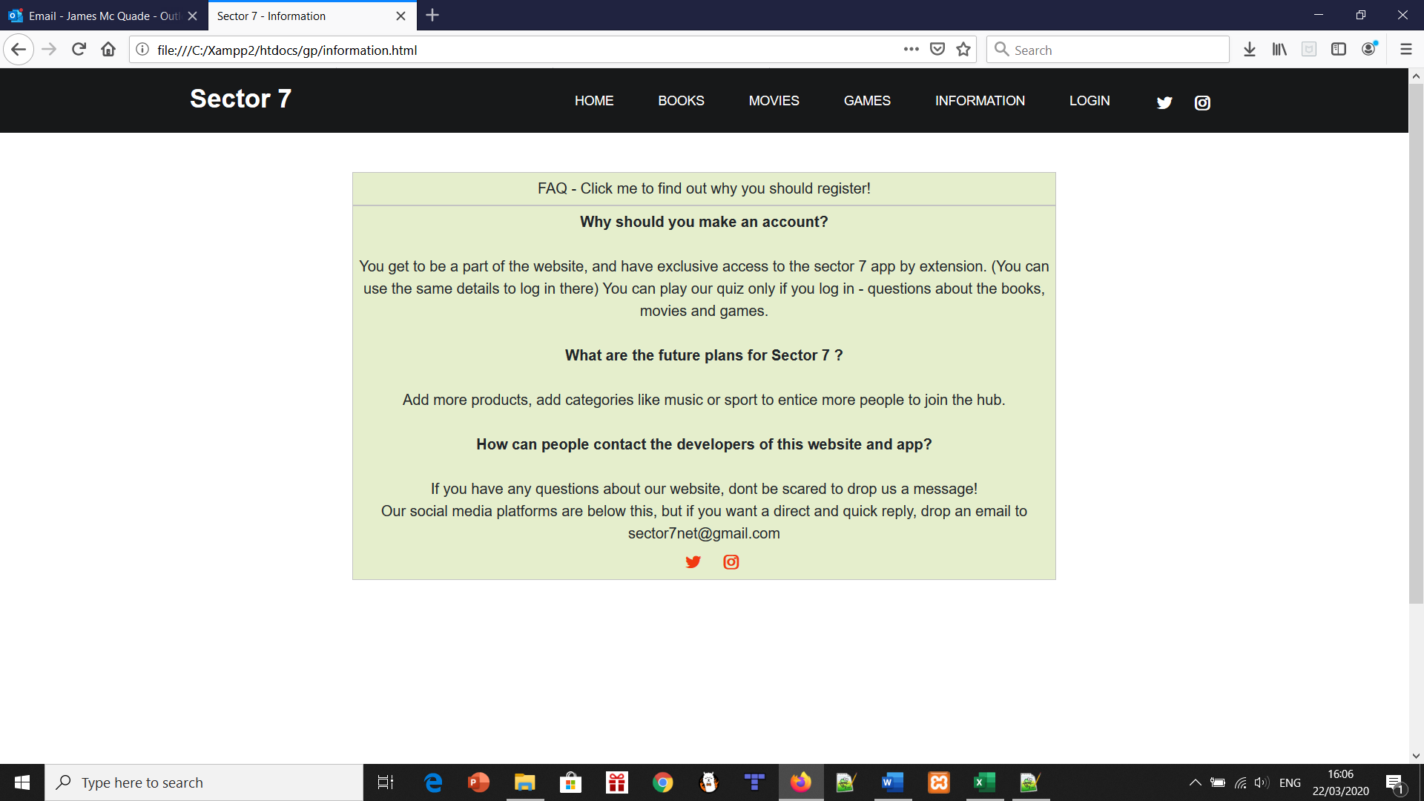

The logged in version of the information page has a more developer feel to it. We give info on how long it took to do the project overall, what languages we used (Described in the software architecture heading before the sprints above) and whether or not we have plans to put the app on the relevant stores.

As you can see below, this is the logged in version.

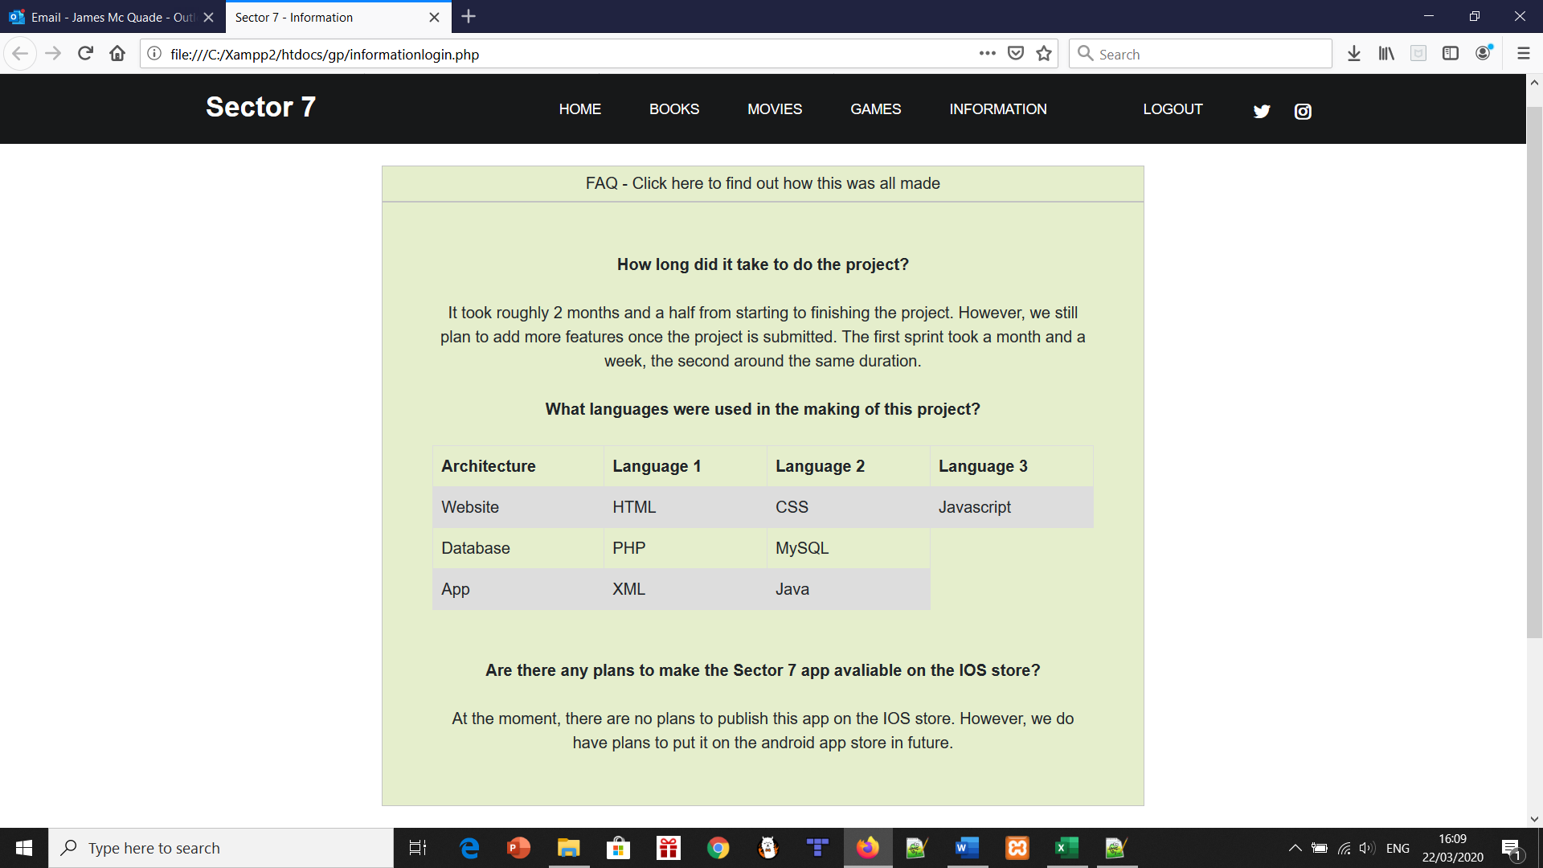

Browser compatibility:

It makes no sense to build a website that only functions to its full capacity on one browser. We decided to put in code that makes it available for Internet Explorer edge. Further testing shows that it’s fully functioning on Firefox and Google Chrome.

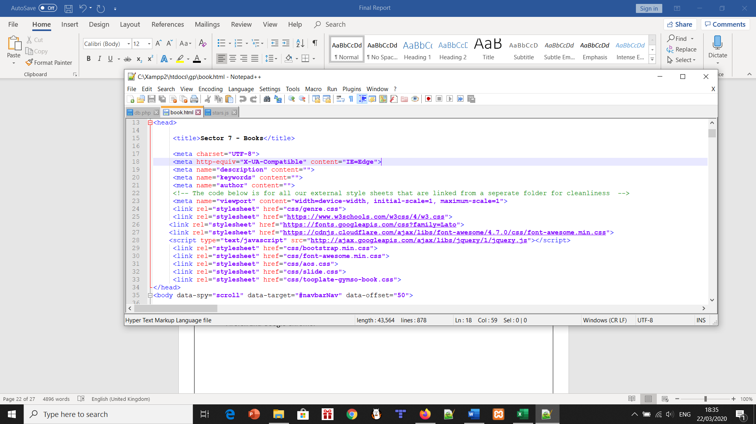

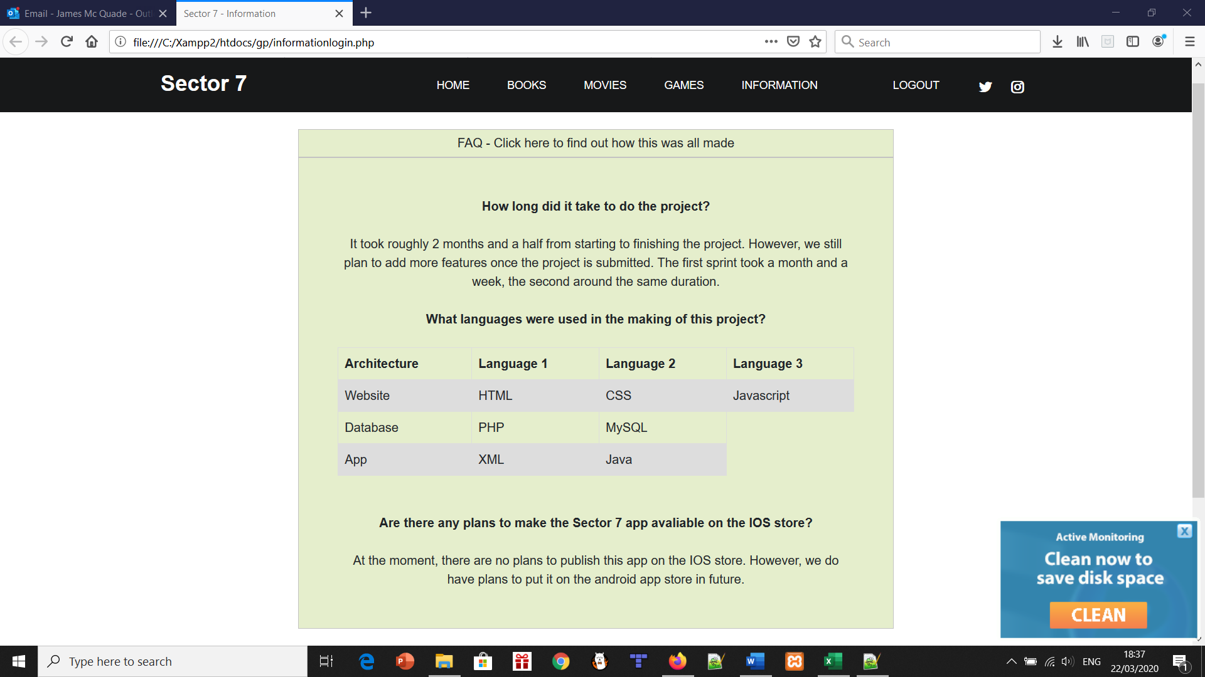

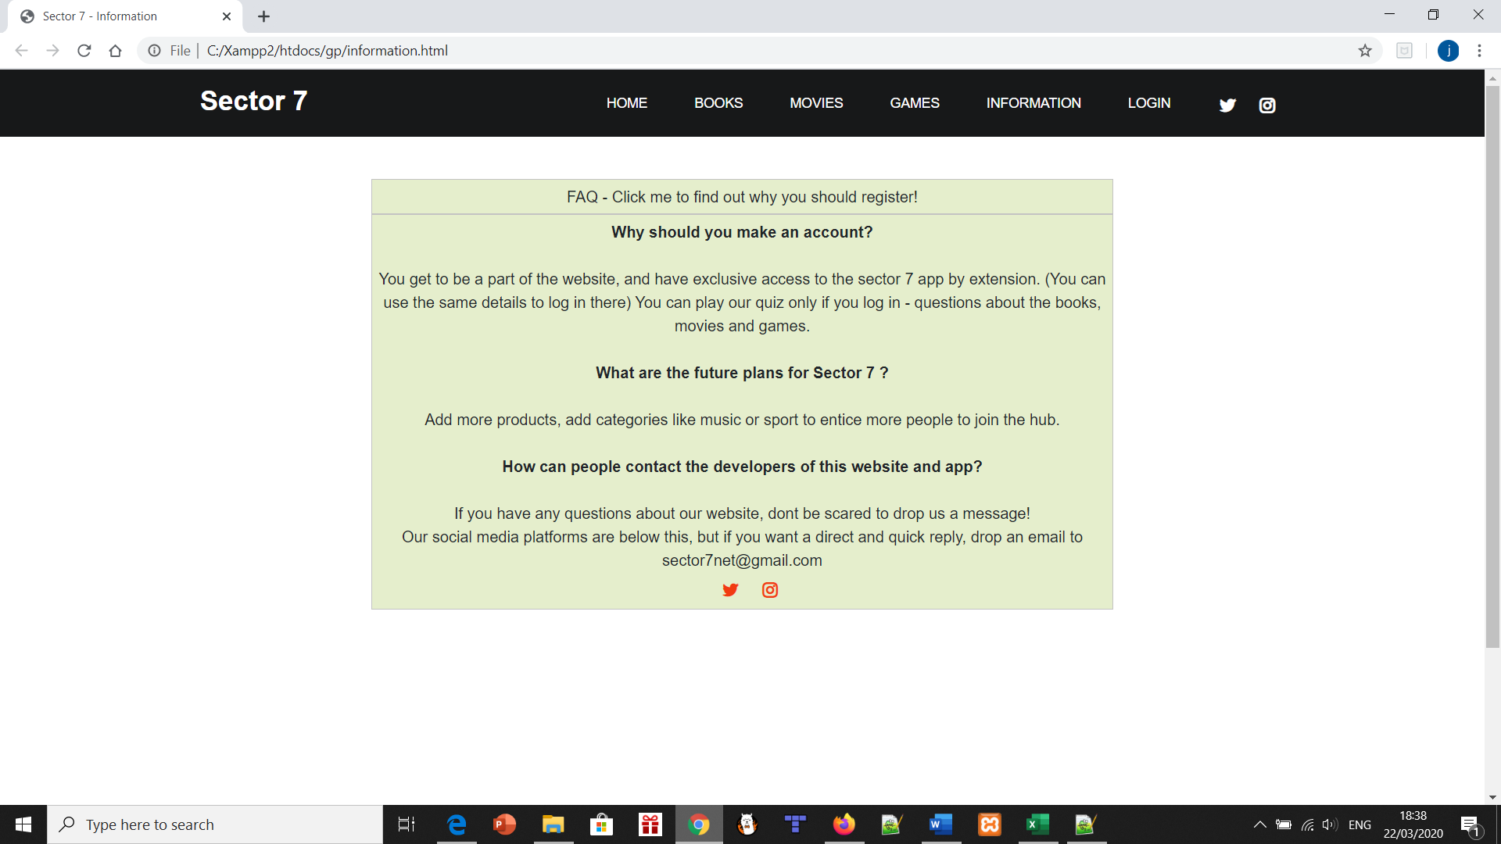

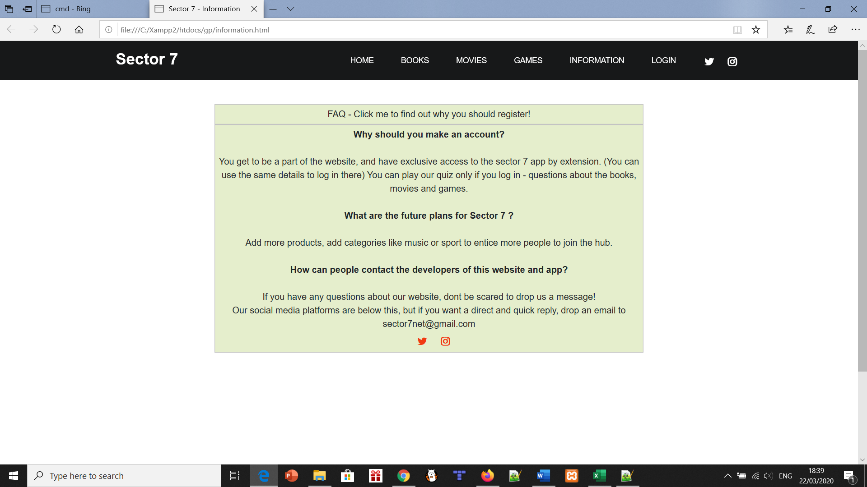

The screenshots above show the testing – it works perfectly on all three browsers. Therefore, it fulfils our plan of making it compatible with enough browsers.

App tidy-up:

This involved dividing up the three main books to each of us. We took the template/base that we already created and filled in the info from the website onto the app. Dillan took movies, James Cummins took games and James McQuade took books – consistent with what categories we took on the website, naturally.

Proper code commenting:

This is something that we’re used to doing on our assignments – the reason is to help people understand the features and code in general if they’re not familiar with it. We again divided it between the areas we did. We took great care to comment on all medium to large features along with things like the navbar, difference between logged in versions and guest (Like having the user’s name as a page pop up when logged in) along with the scripts.

Some examples are shown below.

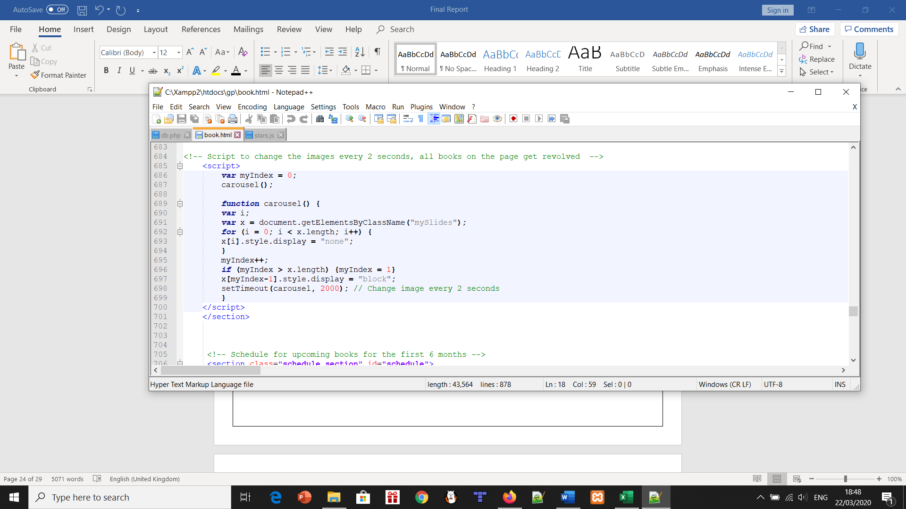

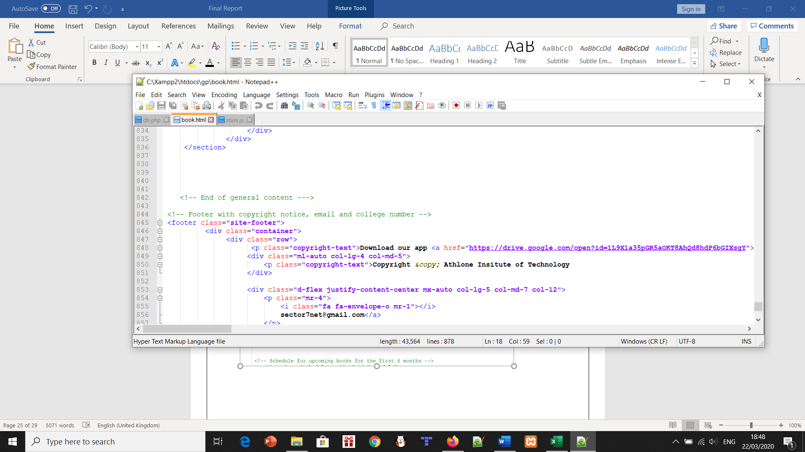

Link app and database:

So as mentioned earlier James McQuade and James Cummins decided to make the app a mobile version of the website, however what we didn’t want was for the user to have to re-register to use the mobile version this included having to link the databases together. This was done by a simple couple of lines of code that basically allow the database to be accessed via the mobile version and by the web version. This was so the user could use the same credentials they signed up with for example if they signed up via mobile, they could use them same credentials on the website. In the original draft up idea for the app we wanted to do something much bigger and complex we wanted to re-create the whole website on android studio. After some discussions we realised that not only would this effect the amount of time and resources we could put towards the website, we also realised from a logical point of view it would not make sense as it wouldn’t give the user much of a reason to sign up to the website. This is why the app while still having all features is ultimately a stripped back version of the website.

Product quiz:

The original quiz for guests has four questions, one for each category and then one on the categories themselves. This is the entrance to the proper quiz, which can be taken when you register an account and login.

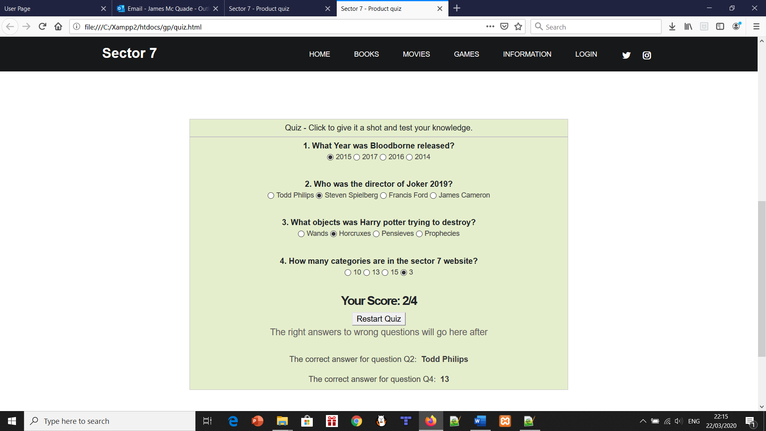

We decided to do this so the users could interact with more features and it also gives them added incentive to really take in the info on the product pages. We added a safety net, so if you get any questions wrong, we’ll tell you which. On the flip side, if you get them all right, we congratulate you!

User page:

This was personalised for the user. We added a thank you from us to them, along with the product quiz. This was only accessible via the user page. There was also a link to the review/feedback box page along with a personal link to the app we made.

We decided to add the thank you paragraph as a personal message to people. The next paragraph shown below explains the quiz pretty well. That’s if you haven’t tried the base quiz with 4 questions instead of the real quiz.

The next link shows the feedback page which will be described further in its own heading.

We figured we’d put the app itself on the website. It’s on the bottom of every footer/page along with clicking the down arrow symbol where specified here.

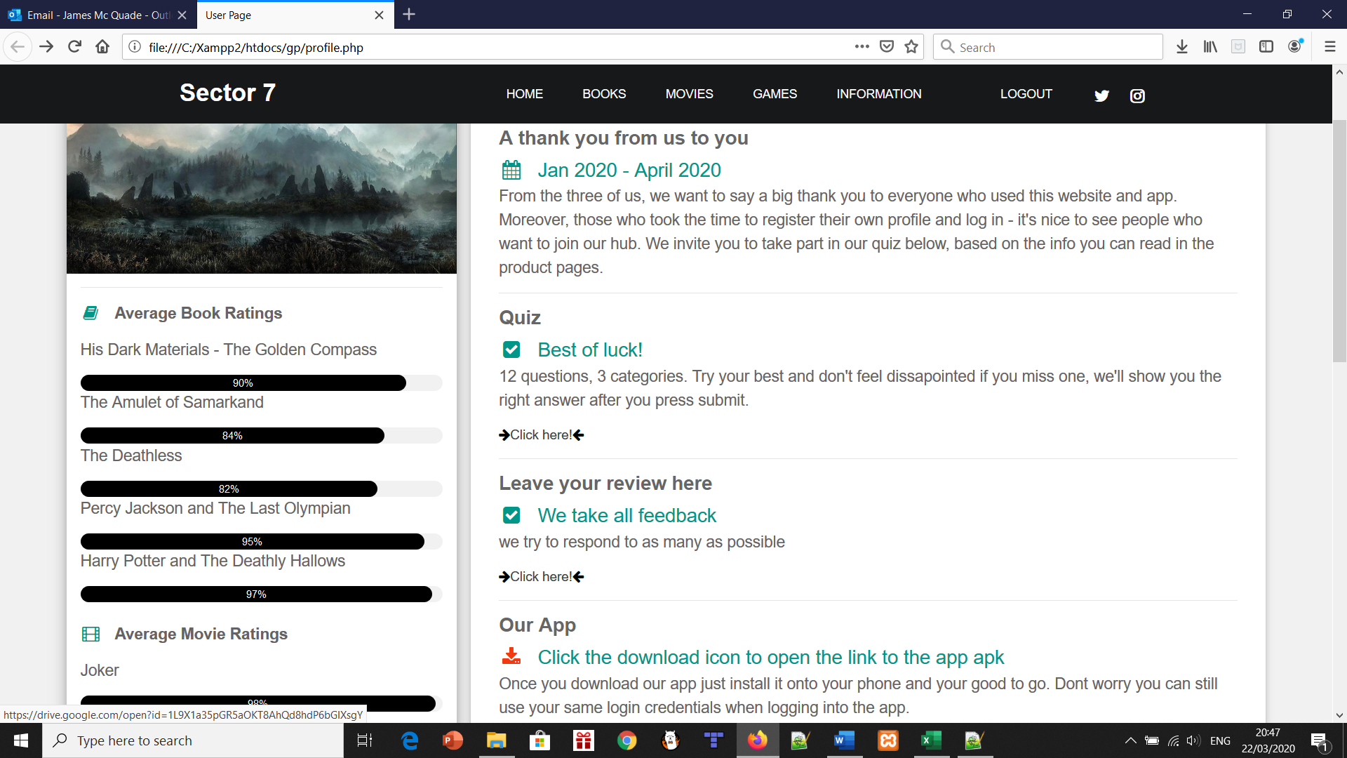

The review ratings from before were done two different ways – in % form and out of 5 stars. As a result of this, we chose another method to display them, which was getting the average of the three reviews per product. The user can quickly glance at the ratings and see straight away which is the most critically acclaimed.

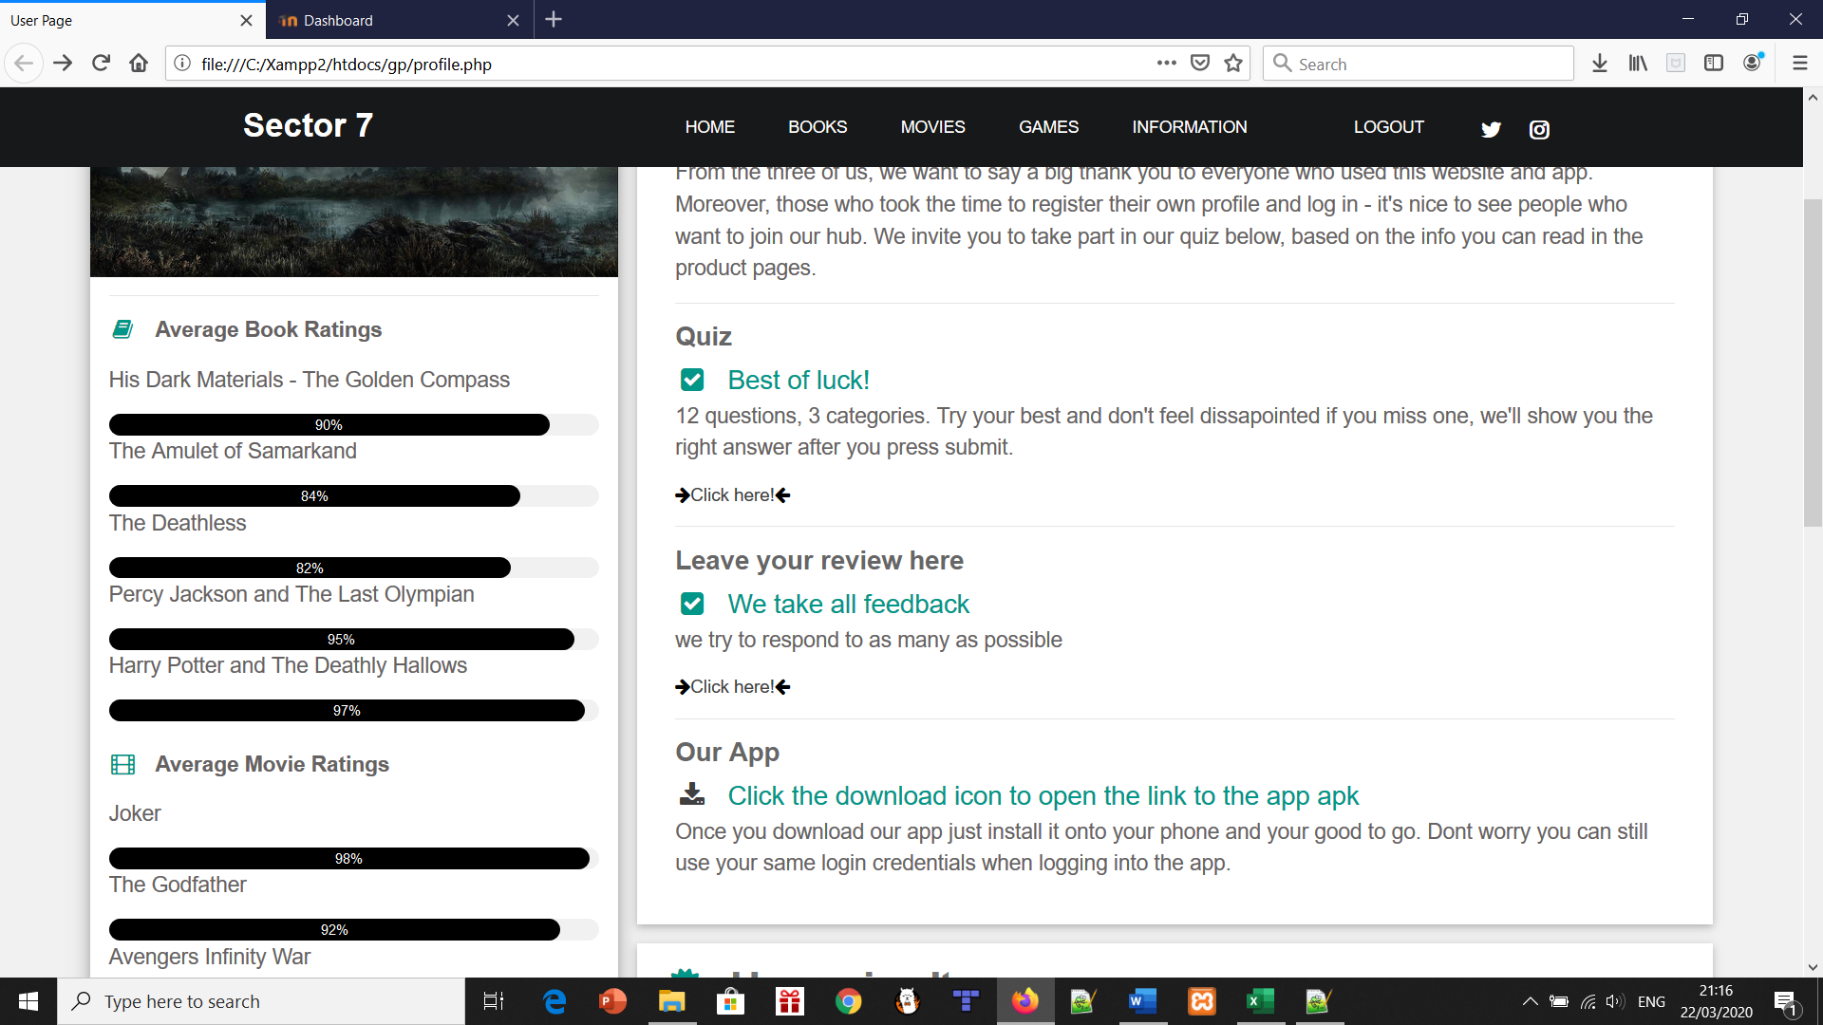

The following screenshot was the original user page which was improved upon greatly. There’s one upcoming book , movie and game from each timetable in the books, movies and games pages. They give the date, name, genre and general description. It’s a nice little sneak peek to future content.

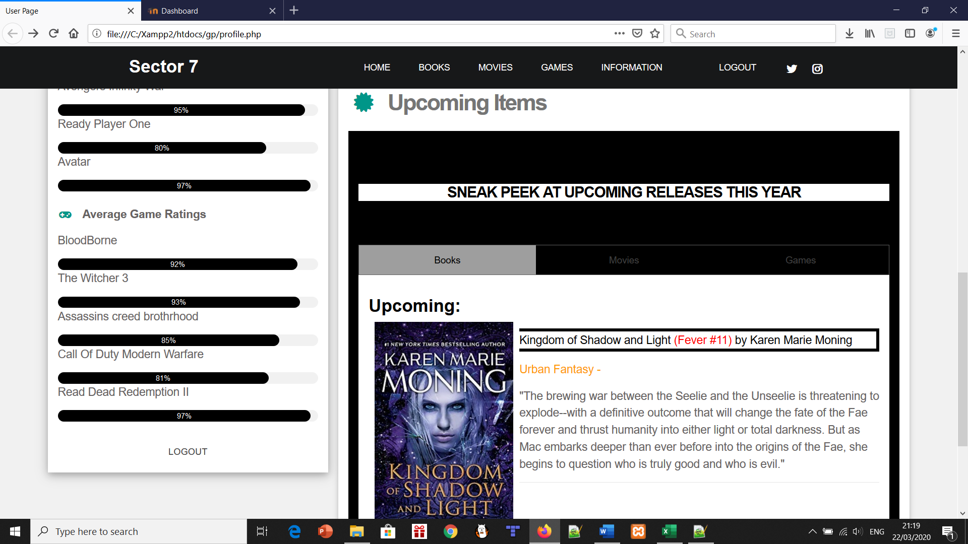

Overall, the user/profile page is a nice feature we added in. It really makes the database and login method stand out when such a page is done.

Review box:

The review box was a previous idea in sprint 1. That plan was to send feedback to our email. Instead, we’re keeping the feedback in-house and visible to all. We can also delete any feedback if we think it’s hateful or abusive.

You simply add in your username in the first box and write your feedback below it. It can be on any book, movie or game, the general look of the website or the app – whatever you want. You can even suggest new ideas for us! This is done with the aid of a second database we created a second database as we did not want to risk breaking our original working one yes you can make the argument they are not linked, however the only way to get access to this feature is if you are a logged in member. Which can’t happen unless you sign up so in a way they are connected by logic just not by code.

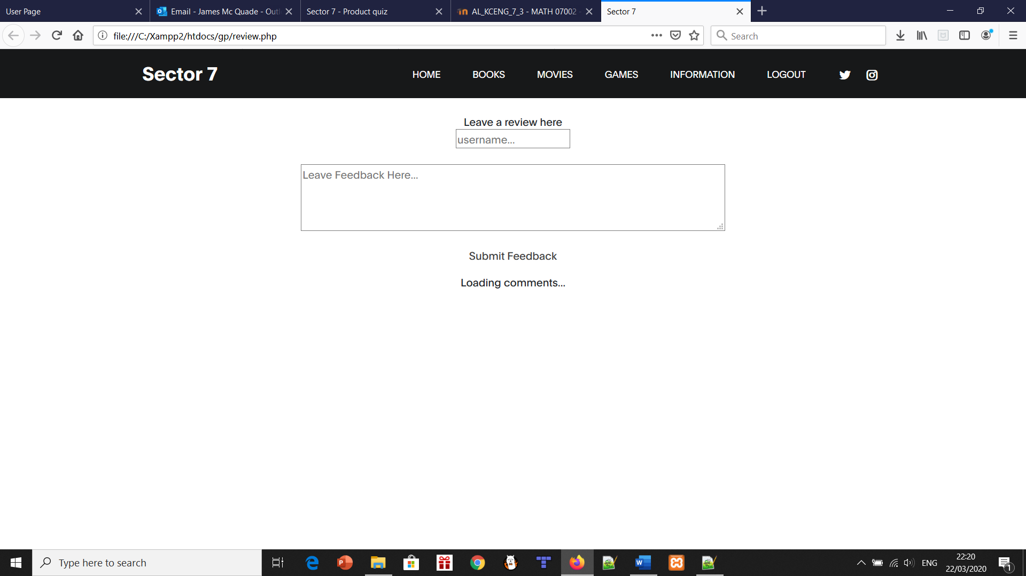

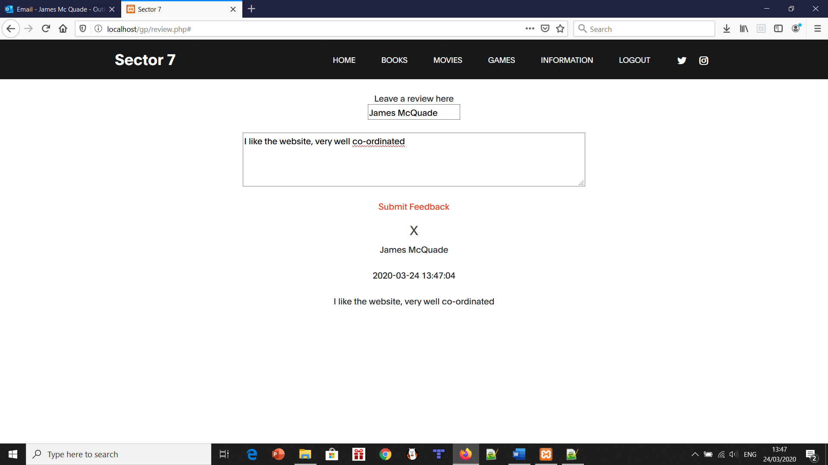

# System Architecture

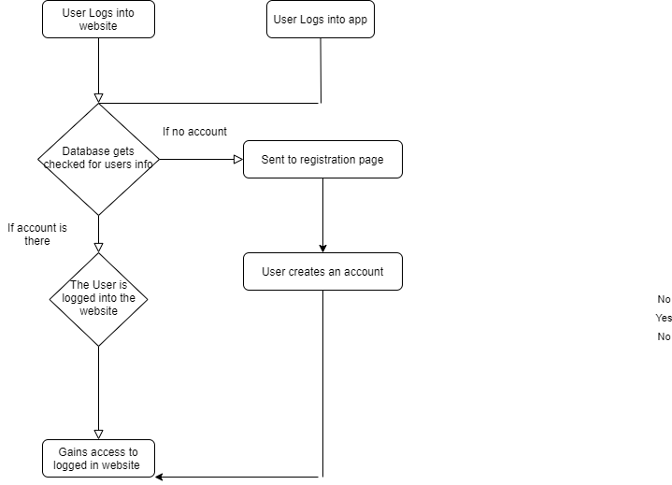

Here we have a diagram of the system architecture. As you can see our project is heavily reliant on our database. Naturally, everything must be passed through the database - for example the login credentials of the user must be verified by the database before the user can login to the website. If the user has no account or incorrect details, they will be re directed to the registration page. This is where the user can create an account to login. As you may notice the app follows the exact same path. This is because the app accesses the same database as the website. This allows the user to create an account on the app that will also work with the website and vice versa.

# 

# Screen shots

Index.html

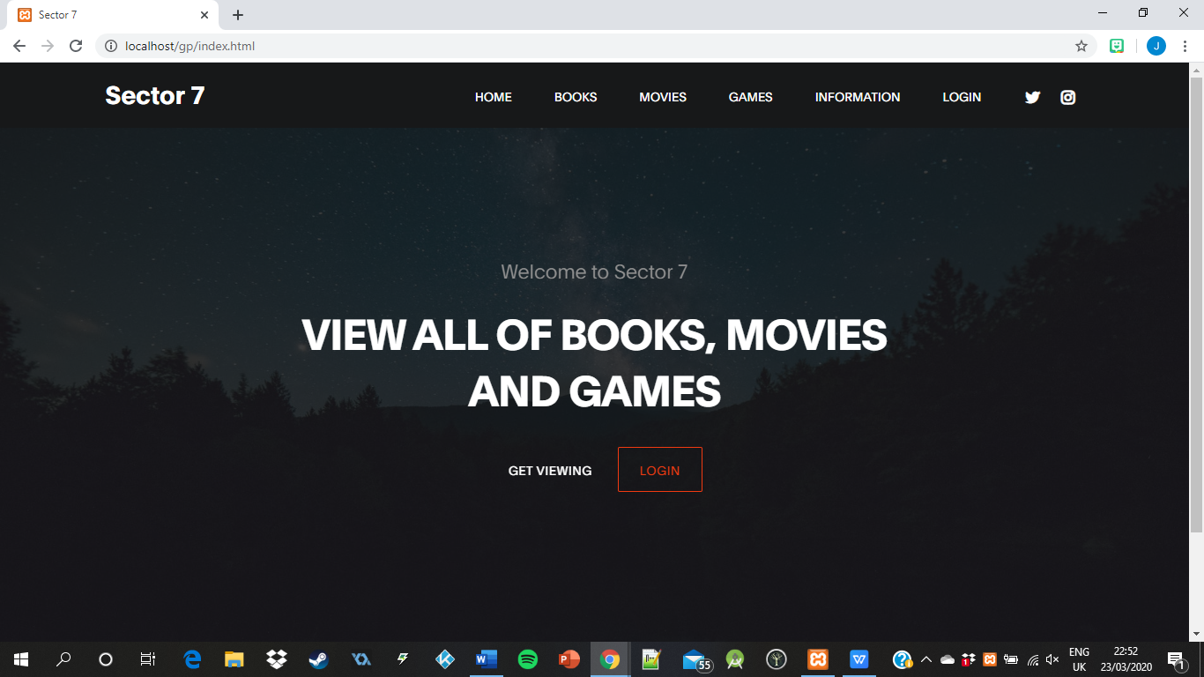

Books.html

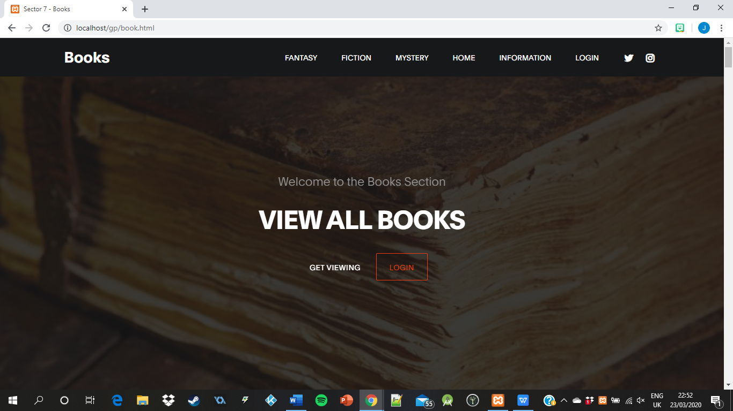

Games.html

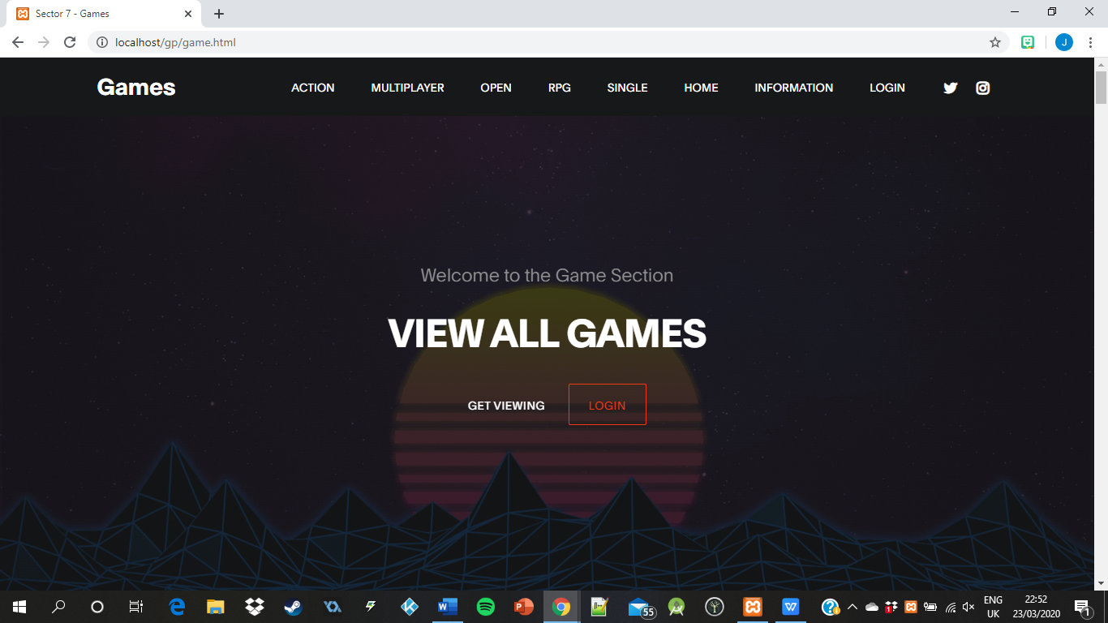

Movies.html

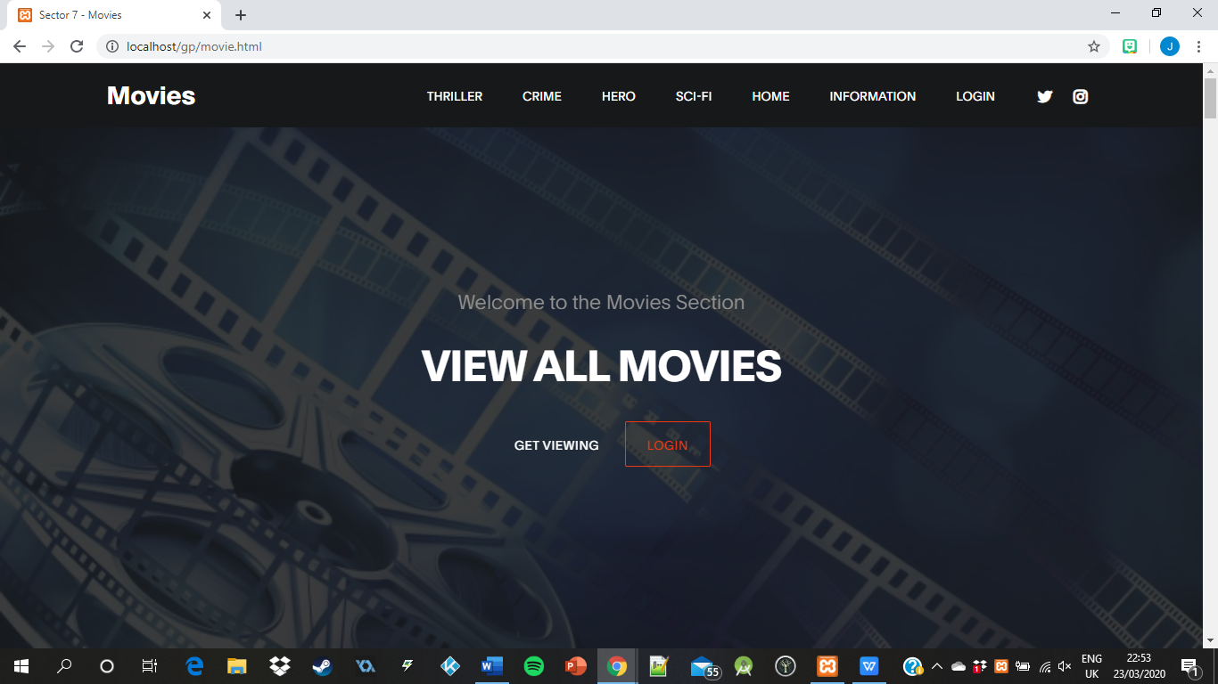

Xamp with working database, username and password shown

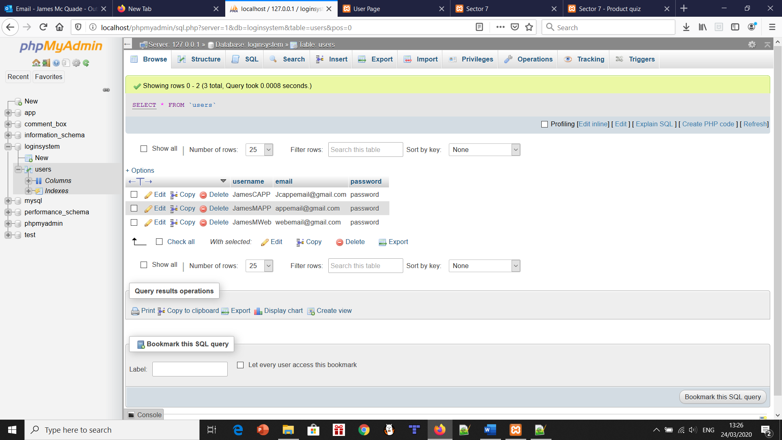

Information.html

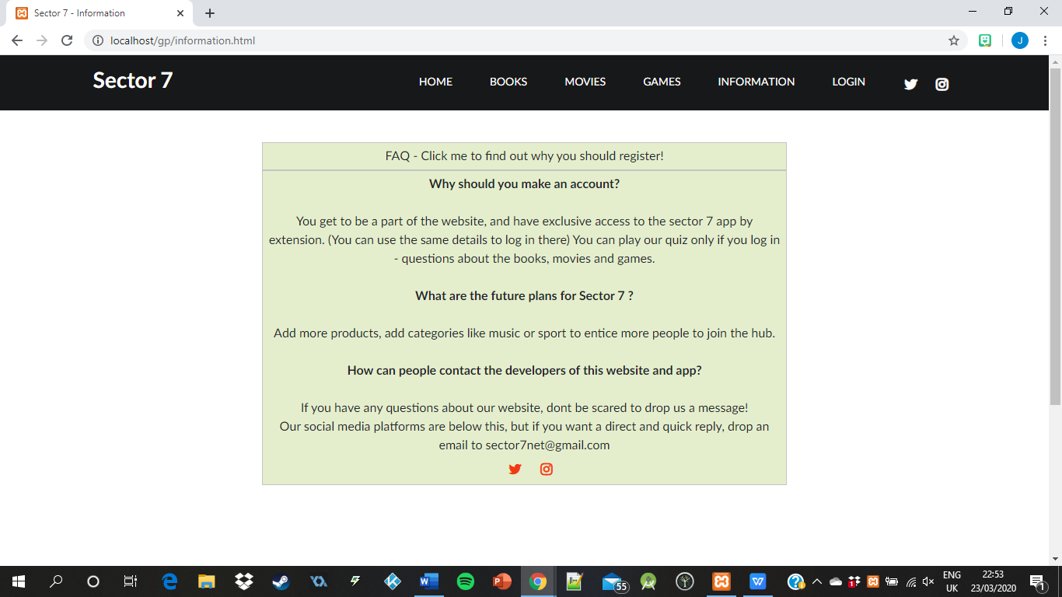

Information.php

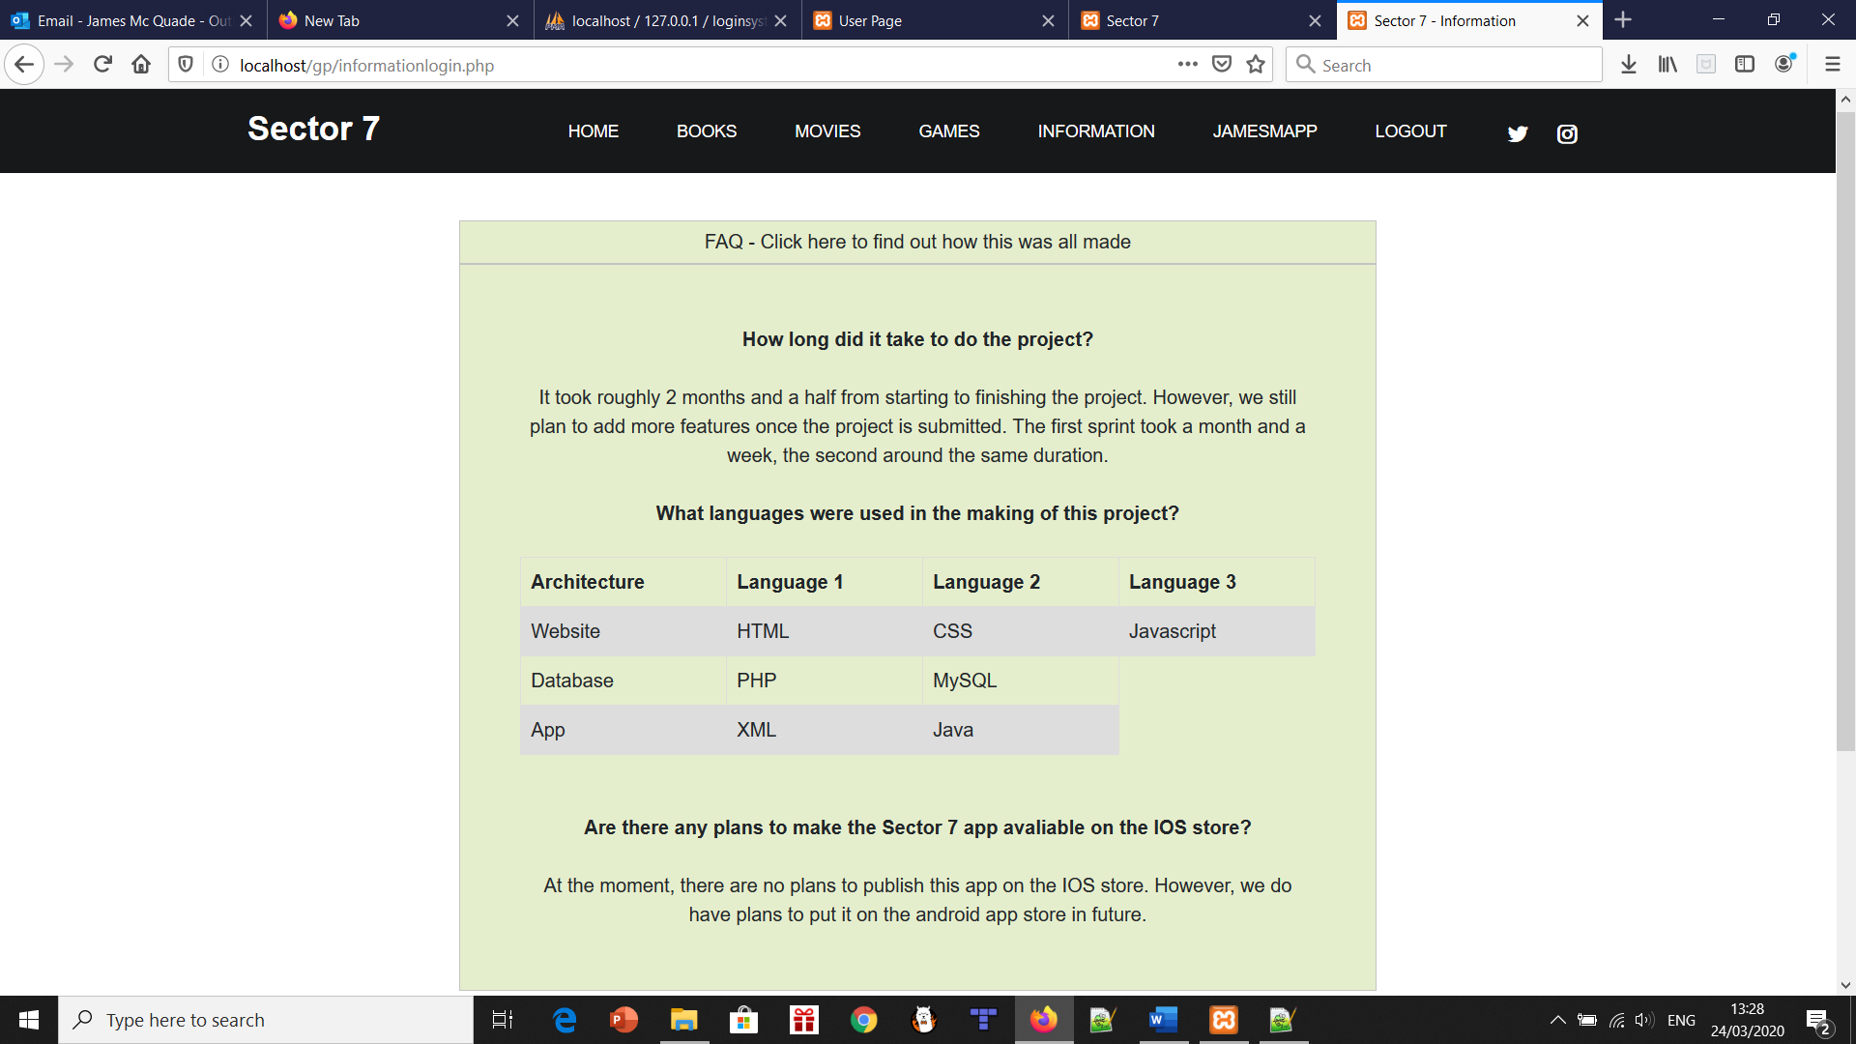

Profile.php

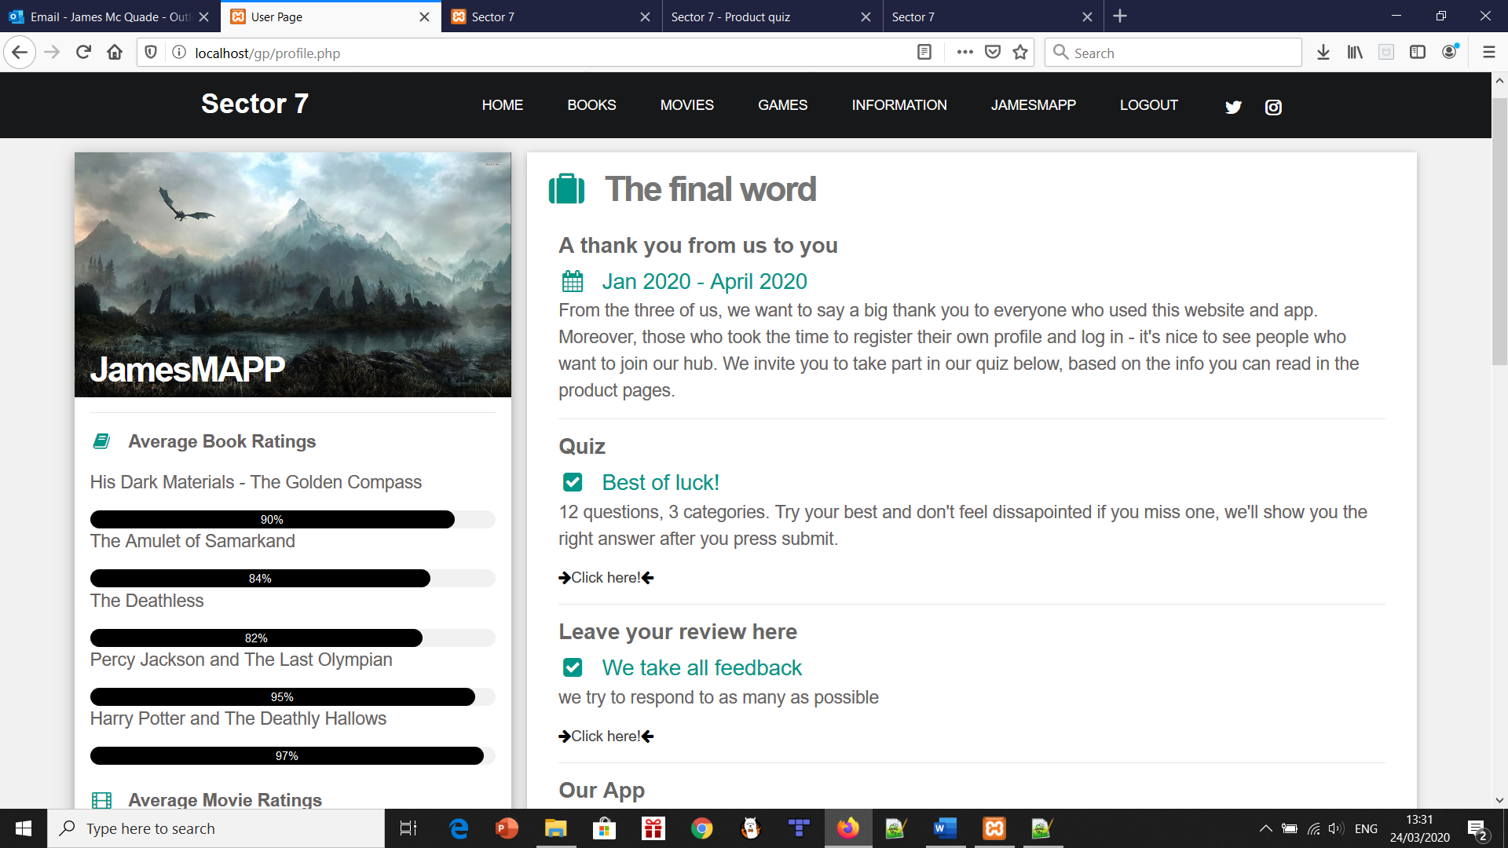

Quiz.html

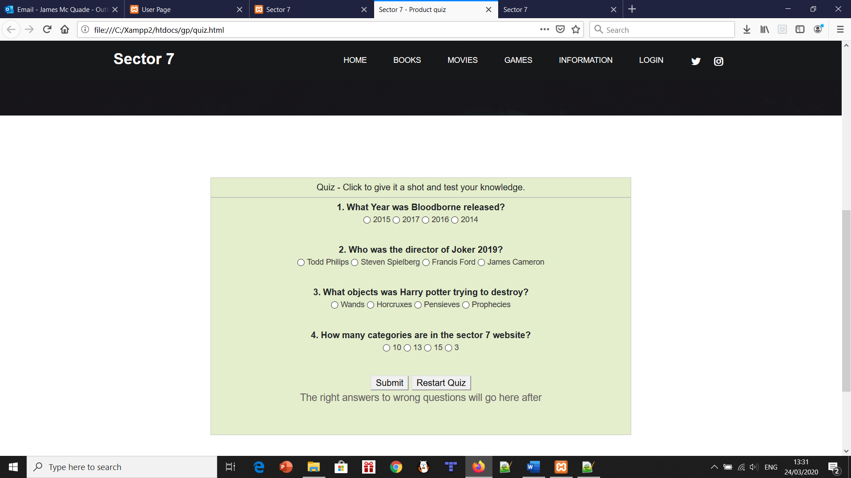

Quiz.php

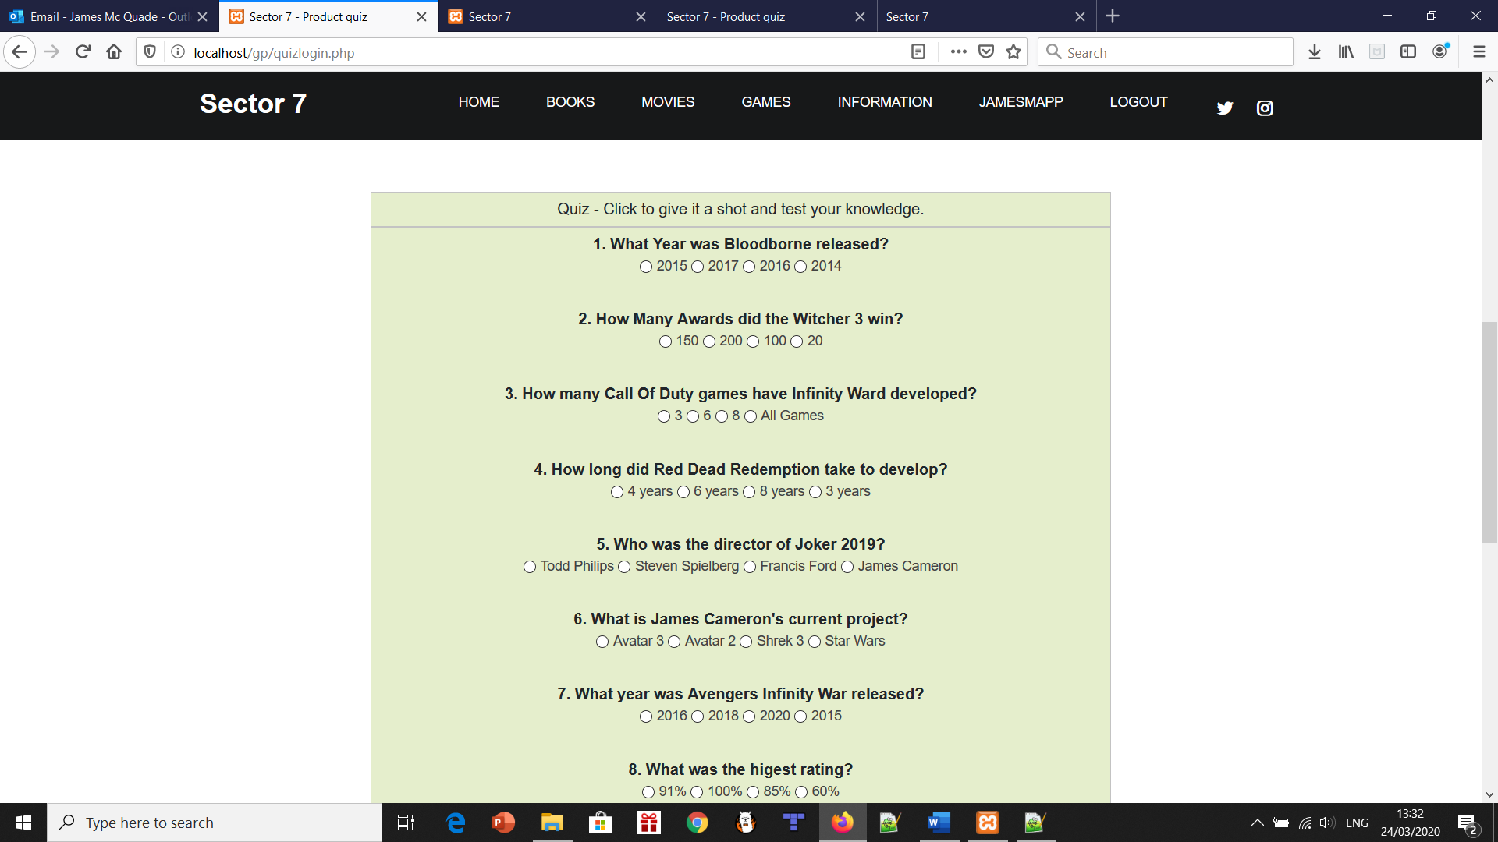

Review.php



# What went wrong?

# 

As it was at least a two-month ongoing project, several things went wrong. However, that’s to be expected. We learned from our mistakes and planned accordingly.

One thing that was a small error was the creation of the Facebook account. We had made an Instagram and Twitter, so what was the harm in making a Facebook account? Overall, this wasn’t really an error, at least by us three members. We tried to make an account, first a personal account. Facebook sends your details away for verification and we waited 3-5 days. Then we found out they disabled or said no to us making the account. We then tried to make a business account for the website and were met with the same resistance. This wasn’t really a problem overall, but it would have been nice to have an account on the three biggest social media platforms out there.

An error encountered with the CSS was the navigation bar. We tried to add a dropdown feature, but the problem was, once minimised, it overlapped each section in the navigation bar. To fix this, each page was given its genre to create a cleaner and more navigable nav bar.

Another thing that didn’t work out was encryption. Now when we say it went wrong, we don’t mean it was a total disaster because it wasn’t. What was happening was, we were using md5 encryption to protect the passwords, this was being done in the php code. Now that wasn’t the issue, the passwords were being protected. The issue arose when we linked the database to the app as we couldn’t figure out how to decrypt the password in java. This was a knowledge error on our end. We are aware of what had to be done to fix this issue, but the team struggled to find a solution. We even tried other encryption methods, however none of them were successful. In the working world we are aware encryption is an essential function, however due to time and resource constraints we decided to remove this feature completely so the project could progress.

# What are the new features if you register and login on our website?

The user page has a whole host of features including the full quiz, direct access to our app (Which is accessible on every other page at the bottom), a sneak peek at upcoming products and the review feedback page.

Along with this, the FAQ page changes to incorporate more specific programming information.

# Project Conclusions

* 1. Success of Implementation
  2. Team Member 1 Reflective
  3. Team Member 2 Reflective
  4. Team Member 3 Reflective

Success of implementation:

We set out to make a hub for book, movies and games lovers. We knew we’d need to create a database in some form, maybe an app as well. We wanted there to be enough info on each product to entice whoever is reading it to look at its Wikipedia or even buy it on Amazon.

Throughout sprint 2, we needed to add actual features that the user could work with and interact with.

The app had to work well with the website – we just didn’t think of linking the databases before sprint 2, when we evaluated it.

Overall, we implemented most if not all our initial plans. The website really does feel like a hub, or a small store system of books, movies and games. There’s plenty of info on the product, the author, developer or director to get you interested. Of course, if it’s your genre – we added several genres for everyone to have their own area.

Interactive features like the quiz, feedback form or drop-down FAQ pages mean the user isn’t just scrolling through information, it breaks it up quite nicely. The app goes hand in hand with this, as you can rate any book, movie or game out of five stars along with reading about them. Of course, this is when you log in.

James McQuade reflective:

This was the biggest project I undertook during my college years. Throughout it, I learned how to be a scrum leader and learn new languages like PHP. I knew how to understand the inner workings of a database. The skills with working in a team will really help in further jobs, as I wasn’t used to constantly checking in with updates or ideas every second day.

We worked well as a team but there was ups and downs, as there is in any team project. We all knew each other’s skillsets, so we divided up specific areas to the person that had the most expertise. One negative of us getting the workload done early was during sprint 2, some work was done later than it was requested or not up to the standard from sprint 1. This was eventually cleared as we worked on improving things like the user page to a proper profile page.

One thing that was nice to see was applying most of our skills learned through the first years of our course towards this end project. It validated all the work previously done. Combining all these was difficult but the base skills could be seen from the start, it was just a matter of adding in the more advanced skills too.

Generally speaking, I’m really proud of how the project turned out. It’s nice to submit such a big project and know you put in a lot of effort and it looks as well as can be. It was fun to work in a high-pressure project for months, despite what some may think – it forced us all out of our comfort zones regarding databases and some login features which is a good thing.

James Cummins reflective:

Overall I highly enjoyed this project as I feel it has helped me gain many new programming skills especially when it comes to dealing with databases and user-based applications. As well as this one of my biggest take aways from this project is the new skills and knowledge I have gained in php. Php was not something I was at all familiar with up until this project and I can now happily say it is one of my more preferred ways of coding due to the amount it can do and the simplicity of it to understand.

I feel myself and the team worked very well together as we each had our own strengths and weaknesses however these weaknesses didn’t cause any issues as we all would take a section that played to our strengths. I feel however our biggest strength as a team was our ability to meet deadlines and be on schedule as it is no secret how early we got finished. This was due to our own initiative to meet up multiple times outside of class and our ability to come up with ideas.

However no team is without its flaws and we certainly had moments where we dipped in motivation this was because we either couldn’t come up with new ideas and thus causing frustration. As well as the fact that we would work more than the required amount causing us to burn out.

In general, I am very happy with our final product as it is a great reflection of our dedication, persistence and passion as students. Now of course there is other things we could add but we didn’t want to oversaturate the website we wanted it to feel user friendly and not be too much for the user. I feel we accomplished the perfect balance of content, features and facts very well.

Finally, the thing I am happiest about it the fact we were able to show off all of our skills that we have learned over the course of this degree and put them all together into one project. This, to me, is one of the most important things this project has done for me.

James Cummins

Dillan Deegan reflective

# References

1. <https://stackoverflow.com/questions/1205135/how-to-encrypt-string-in-java>
2. <https://www.quora.com/How-do-I-connect-an-Android-app-and-website-with-same-database>
3. <https://blog.templatetoaster.com/xampp-phpmyadmin/>
4. <https://www.w3schools.com/php/>
5. <https://codewithawa.com/posts/complete-user-registration-system-using-php-and-mysql-database>
6. <https://www.tutorialrepublic.com/php-tutorial/php-mysql-login-system.php>
7. <https://codeshack.io/secure-login-system-php-mysql/>
8. <https://www.youtube.com/watch?v=yUWuQTQw7tc>
9. <https://github.com/>
10. <https://www.w3schools.com/html/>
11. <https://www.sourcecodester.com/php/7191/how-create-comment-box-using-php-mysql.html>
12. <https://www.codebrainer.com/blog/registration-form-in-android-check-email-is-valid-is-empty>
13. <https://www.apachefriends.org/index.html>
14. <https://www.udemy.com/blog/xampp-tutorial/>
15. <https://www.tutorialrepublic.com/php-tutorial/php-mysql-login-system.php>
16. <https://www.amazon.co.uk/>
17. <https://www.youtube.com/watch?v=9YUv2yonio0>